**Social Media Analytics Primer**

**2017 Copyright Dr. Anitesh Barua, UT Austin**

***Under no circumstances can the copyright sign be removed, and doing so constitutes a copyright infringement. You must first seek my permission to use this primer for ANY purpose other than this course and/or assignment.***

**Table of Contents**

1. Installing Python on Your Computer: Page 1 (For Mac, go to Page 8)
2. Python Scripts: Page 13
3. Getting Twitter Access: Page 14
4. Accessing social content using Web Scraper: Page 18
5. Unsupervised Sentiment Analysis with SentiStrength: Page 31
6. Network Analysis with NodeXL Page 38
7. Multi-dimensional Scaling (MDS) with XLStat Page 50
8. Network Analysis with Gephi (free alternative to NodeXL) Page 54

**1. Installing Python on Your Computer**

Below you will find instructions for installing Python on your Windows computer. Mac users should skip to page 8 for instructions.

**Instructions for Windows users to run Python scripts**

Windows users can get anaconda2 (or 4) from <https://www.continuum.io/downloads> and download the 32-bit version (even if you have a 64 bit machine) **2.7.x** **DO NOT install a later version** like 3.5 unless you are comfortable making changes to the Python scripts on your own.

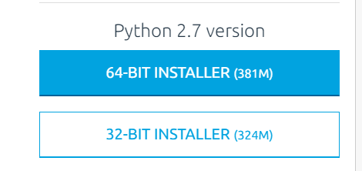

Double click the downloaded file to install. I would recommend setting/changing the install directory to c:\Python27 for ease of access.

Now you will have to use the command prompt. There is another way to use Python for more advanced users, which is described later.

**How to use Command Prompt for Windows (these instructions are required if you are a seasoned IT user!)**

1. Go to “Start Menu” and click on “Run” – alternatively, press + hold your Windows key and press ‘R’.
2. Type in ‘cmd’ to get to your command prompt:

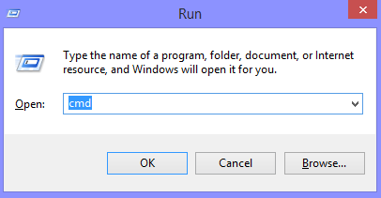

Click “OK”. You are automatically in your Users*UserName* folder as shown below (on my computer)

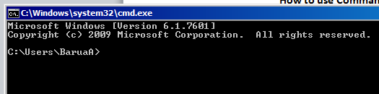

To change directory and to get to C:\, type **cd\**

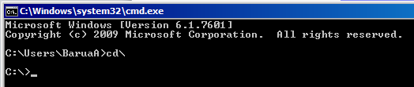

Now type **cd Python27** to get

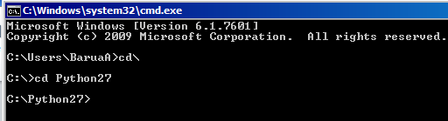

Note: If you need administrator access, type **sudo** before your **python** command to upgrade to admin access. You can do this for anywhere else you get an error message stating that you do not have adequate permission to download a file.

* 1. Now type **cd Scripts** and hit Enter**.** You should be in C:\Python27\Scripts> (see screenshot below). Now type **pip install BeautifulSoup4** and hit Enter, which will install the BeautifulSoup4 library as shown below:

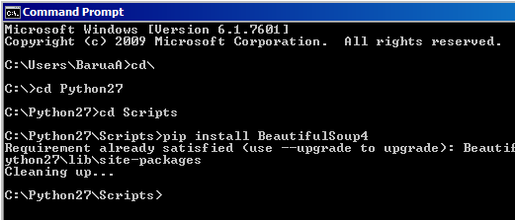

I had installed BeautifulSoup4 before, and therefore got the message that it is already there.

* 1. Similarly, type the following – btw, make sure you are in C:\Python27\Scripts>

**Pip install BeautifulSoup** and hit Enter (note that we are installing both BeautifulSoup4 and Beautifulsoup libraries)

**Pip install unidecode** and hit Enter

**Pip install test** and hit Enter

**Pip install nltk** and hit Enter

**Pip install oauth2** and hit Enter

**Pip install twitter** and hit Enter

Now we need to import some data files that the nltk package will need. To do this, first go to the C:\Python27> prompt. If you are in C:\Python27\Scripts> type **cd\** and hit Enter, which should take you back to C:\> as shown below. Now type **cd Python27** and hit Enter, followed by **python** and hit Enter again as shown below. Now you should see a >>> prompt.

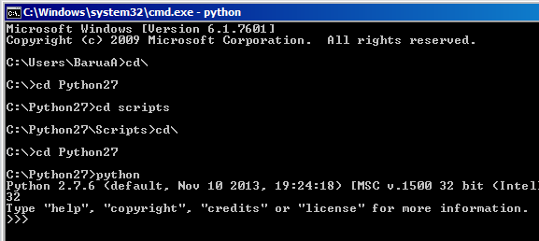

At the >>> prompt, type **import nltk** and hit Enter

Then type **nltk.download()** and hit Enter

This pulls up a window as shown below:

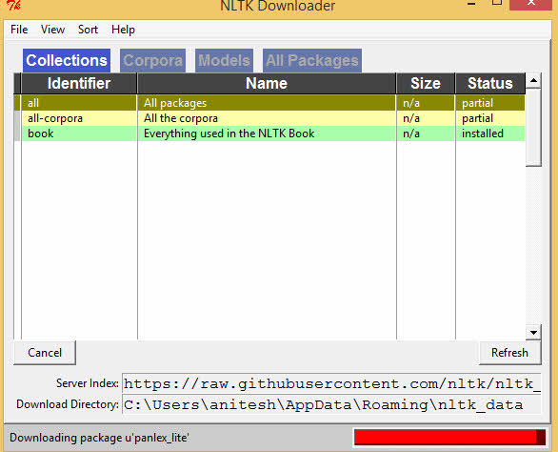

Choose **all packages** and start download.

If everything downloads (it takes a good chunk of time) you should see **>>> True** in the command line. However, of late, one package, panlex is causing trouble toward the end of the download process. If you get stuck for more than 5 minutes with panalex, just cancel the download (it has already downloaded the stuff you need – see the task completion bar is almost at the end when it gets stuck), and in the >>> prompt, type **Exit()** to get out of the >>> shell. Now we are almost ready to run a python script.

**Editing and running Python scripts**

Save a Python script in your **Python Scripts** folder for easy access. You will use Jupyter to edit a Python script.

**Using Jupyter Notebook in windows:**

Search for “jupyter” in windows and double click on the jupyter notebook.

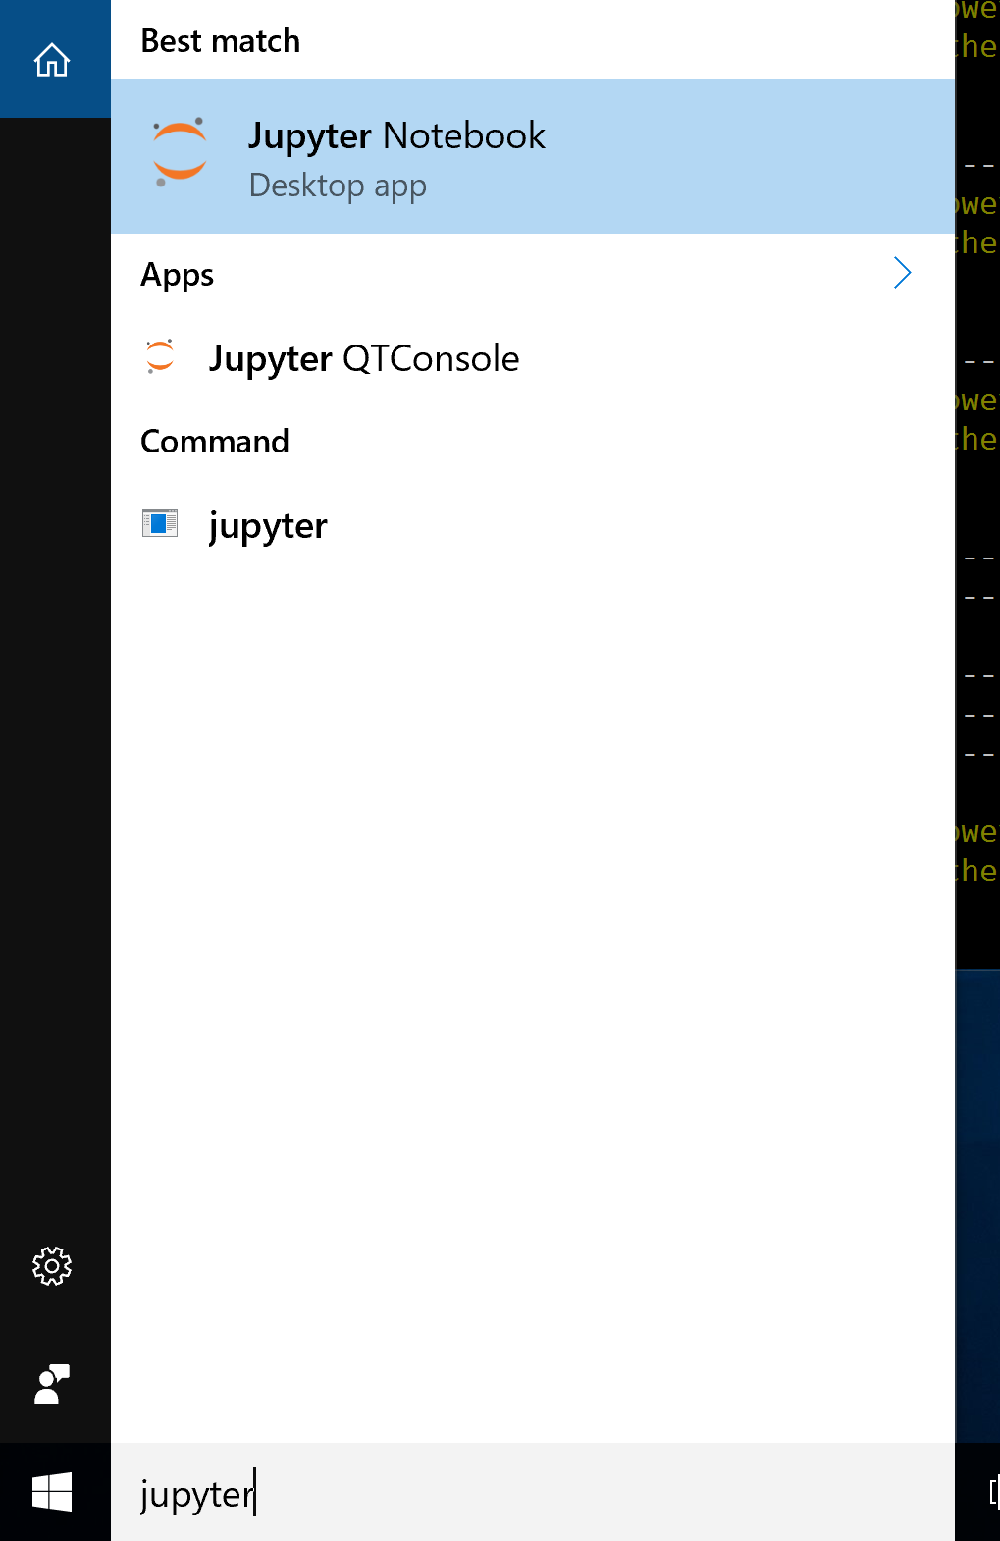

This will automatically open a browser which links to your Documents folder. Make sure that you have all the python scripts in the Python Scripts subfolder within the Documents folder. Below is a screenshot of the browser which shows Documents folder on the computer and I have all the scripts present in the Python Scripts folder.

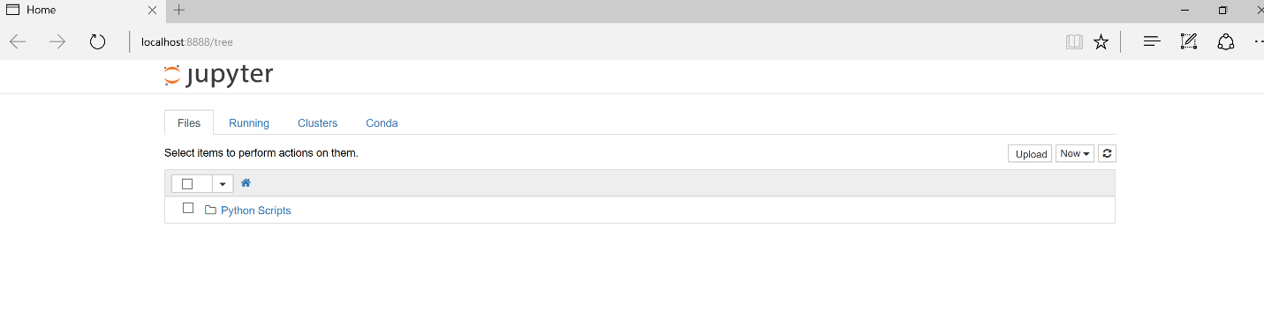

Now open up python script you want to edit and run. Once you edit the script, save it. You have two ways to run the script – either from Jupyter or from the command line prompt.

To use Jupyter to run the script, open a new “python root” to run the script.

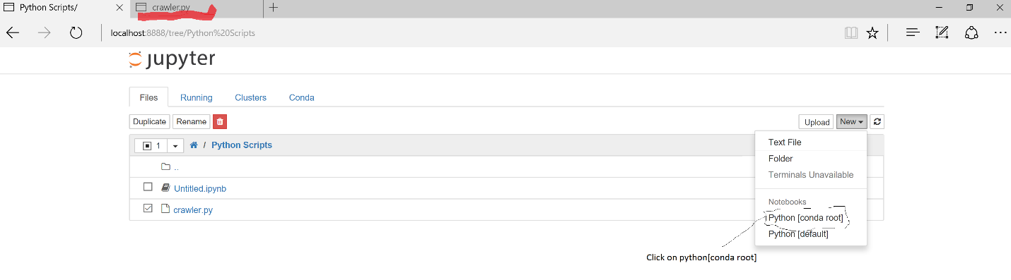

Paste the script into the box. Please follow the figure below to run the code.

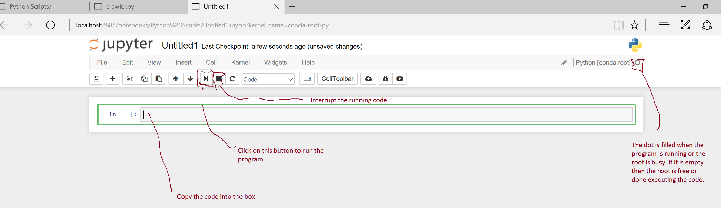

**Some of you may find it easier to run a script from the command line.** Open your command prompt. Type **cd Python27** to get to C:\Python27>

Once in the folder **Python27**, you will run the python script by giving the command

**python path-to-the-script*nameoffile*.py**

**e.g., python c:\users\baruaa\documents\crawler.py**

**Instructions for Installing Python libraries on the Mac**

This instruction is based on OSX 10.10.1 (Yosemite); it takes about 20 minutes to finish.

Libraries you will need to install (instructions provided below)

* BeautifulSoup
* BeautifulSoup4
* requests
* unidecode
* test
* nltk
* oauth2
* twitter

Requirements

* Mac’s admin password, which will be used during the installation
* Good internet connection during the installation

1) Open **Terminal**

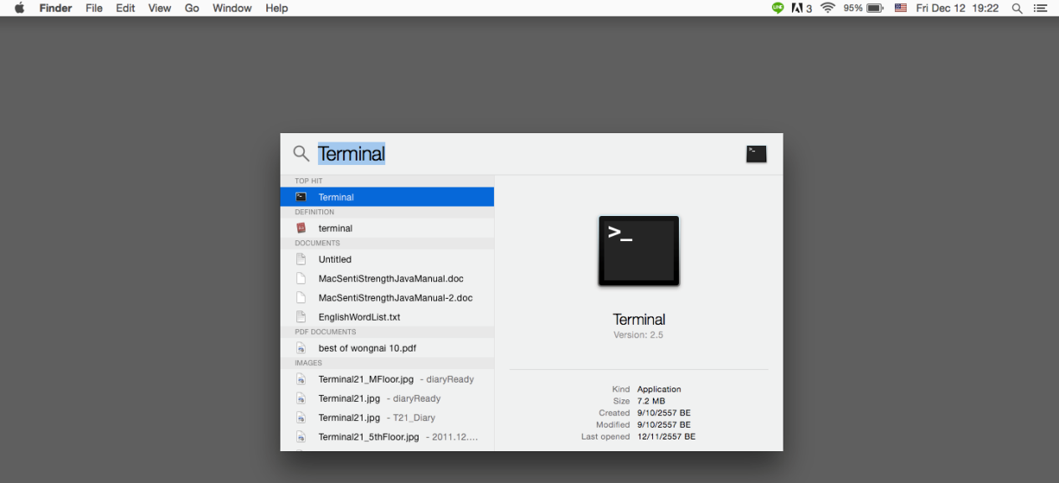

2) At the prompt, type

**sudo easy_install-2.7 BeautifulSoup**

**sudo easy_install-2.7 BeautifulSoup4**

your machine password will be asked, provide it and hit enter then wait until it finish the task. (Ensure there is no error, then proceed to the next step)

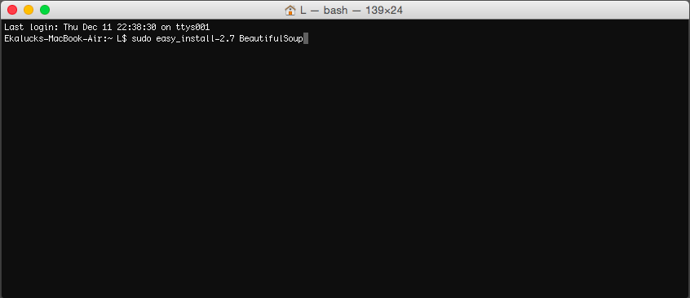

3) Again, at the prompt, type following commands and hit enter one row at a time. (you can copy and paste them into the Terminal)

**sudo easy_install pip**

**sudo pip install requests**

**sudo pip install unidecode**

**sudo pip install test**

**sudo python -m nltk.downloader -d /usr/share/nltk_data all**

**sudo pip install oauth2**

**sudo pip install twitter**

[End of the installation]: Depending on the script you are running, you may have to install a few more libraries/packages. But the process is the same.

**Example: Running the Python script on Mac**

Python script could be run via command line interface, using Mac’s Terminal.

1) Preparation, it is a good idea to have all required files in the same folder.

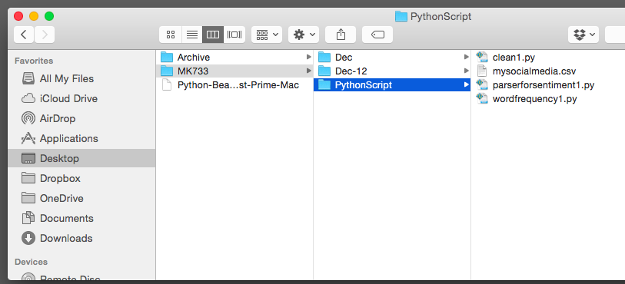

2) Then you will need to know path of the folder. Let’s enable the path bar from the Finder menu

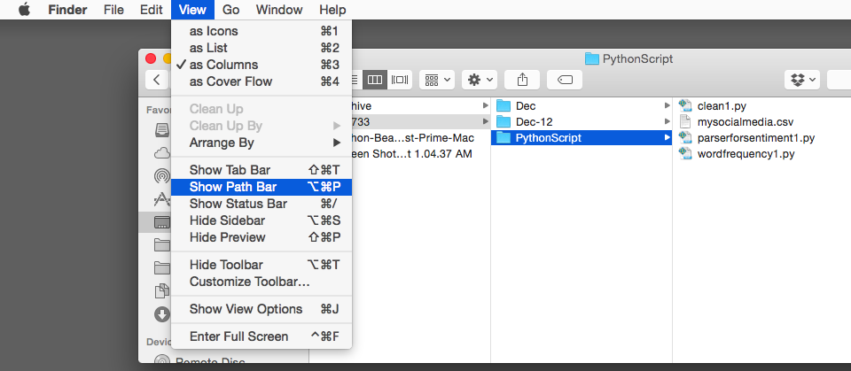

Here comes the path bar!

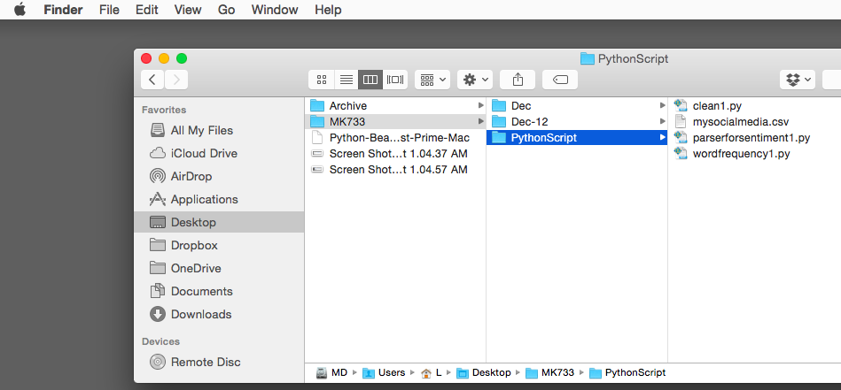

In this example, the path is at **/Users/L/Desktop/MK733/PythonScript**

You should choose a path that is useful for you.

3) Open **Terminal**

4) Change the working directory to the path that contains our files, by typing

**cd <your path>**

For example, type

**cd /Users/L/Desktop/MK733/PythonScript**

(MK733 was a course I was teaching, you may want to use SMA2016 or something else) and hit enter

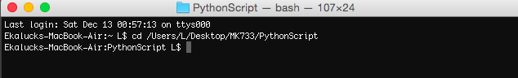

5) Make sure your Python script is in the same directory as above. Now you are ready to run the Python script in this directory, by typing

**python <ScriptName.py>**

**Using JUPYTER Notebook in Mac**

Download anaconda for python 2.7 for mac from the following link: <https://www.continuum.io/downloads>

Double click on the downloaded file and install anaconda. Once the installation is done. Open the terminal and type “jupyter notebook”. This will open a browser with a link to your browser. Please follow the screenshots in section 1.b above to run the python code.

**2. Python Scripts**

**Word of caution: In many cases, you will be running the scripts below multiple times. Make sure you change the output file name before running the script each time to avoid overwriting the previous file.**

**(i) Crawler.py:** This script crawls and fetches content from Edmunds.com discussion forums. You need to change the number of pages to fetch (e.g., 250), and the starting URL -- currentlyset to the Entry Level Luxury Forum, which is what you want for the assignment. The output file name needs to be changed to make sure that if you run the crawler multiple times, a previously generated output CSV file does not get overwritten.

**(ii) Wordfrequency.py** to obtain words and their frequencies. Input file: **Edmunds_Extraction.csv,** output file: **Word_post.csv.** It creates a second output file (pairs of words) but do not use it.For your own data file, change in the name of the input file in the script, make sure the text is in the 3rd column (if necessary insert blank column(s) before the text column to make the latter the 3rd). All input files should be placed in the Python27 directory before running the scripts.

(iii) **Find_and_replace.py** to replace words in your data file. This is useful for replacing models with brands, converting different words into a single word (e.g., replacing ‘engine’, ‘acceleration’ with ‘performance’, replacing aspirational words or phrases with ‘aspiration’, etc. ). To use this script, create a folder called CSV within the Python Scripts directory. Put words and phrases to replace in the file Models.csv file for illustration, and place the file Models.csv in this CSV folder. Make sure your data file is in the regular Python27 directory. Make sure the name of the data file is the same as the name of the file in the script. Now run the script, which will replace all the words and phrases you mentioned in the Models.csv file.

**(iii) Liftcalculations.py for lift values: To obtain multiple lift values at once, edit the edmunds_pair_keys.txt file by putting the entities and attributes (separated by commas) for which you want lift values.**Save it as a text file, and put in the Python27 directory. Now run the **Liftcalculations.py** script which will take the **edmunds_pair_keys.txt** file as well as Edmunds_Extraction.csv to calculate all possible lift values. The output is shown on the screen and also saved as:Lift_Values.csv.

**(iv) parserforsentiment.py:** This script takes three inputs. A **brand** (or an entity), an **attribute** and the **number of words** around the attribute to keep. The brand input is used by the script to ignore all rows that do not contain the word. Then the script retains the number of words specified to the left and right of the attribute word, and creates limit_post.csv, which can then be passed through SentiStrength for sentiment analysis. Stopwords are removed by the script.

**(i) tweetstream.py** to obtain tweets**.** Select keyword(s), and don’t ask for more than 5000 tweets per search. Tweets.csv is the output file.

**3. Getting Twitter Access**

To access tweets, first you will get authorization from Twitter and then use a Python script to collect tweets on any topic of your choice. To get authorization from Twitter, create a Twitter account on Twitter.com. Even if you have one already, I suggest creating a second account with a different email address. Once your email address is confirmed by Twitter,

Go to <https://dev.twitter.com/docs> and click on “manage my apps”. Create a new app by giving it a distinctive name, a short description and a url (this can be any other url like <http://www.utexas.edu>, which does not belong to the twitter domain). Once you create the app, you should see something like this:

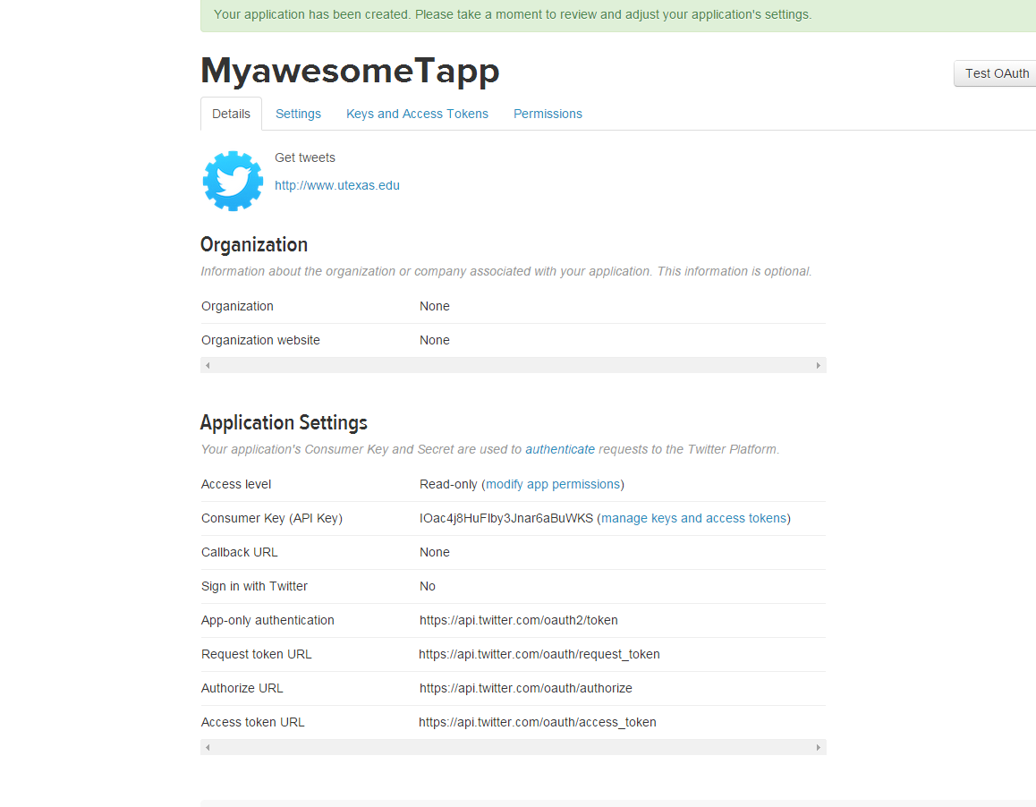

Click on **manage keys and access tokens**, and you should see a page like this:

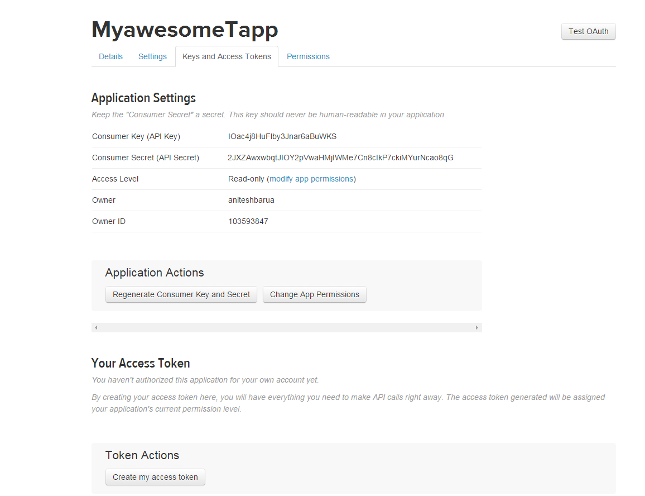



So now you have the API key and API secret. But you also need access tokens. To do so, click on the button **Create my access token**.

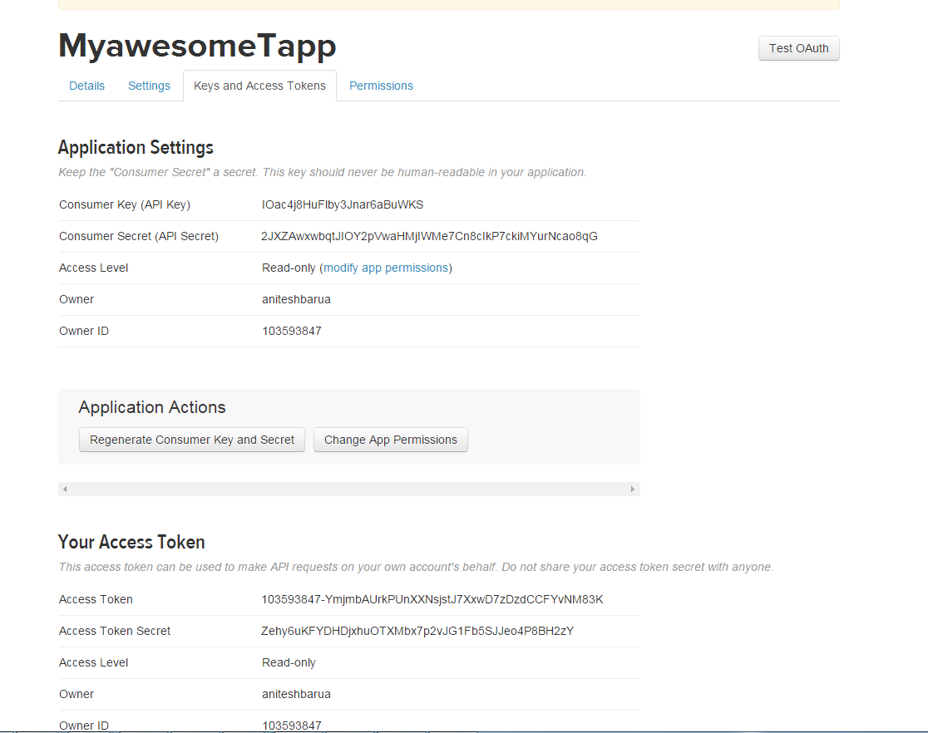

Now you have the Access Token as well as the Access Token Secret. You will copy these 4 keys, tokens and secrets and paste in the right places in the Python script that we will use to extract tweets. But before we do that, you need to install a bunch of Python libraries on your computer.

Go to your Python folder from the command prompt (I am assuming that you have already installed Python), type **cd Scripts**

Then type:

**For Windows users**

pip install tweepy

pip install csv

pip install sys

pip install pandas

pip install json

pip install pyplot

**For Mac users**

sudo pip install tweepy

sudo pip install csv

sudo pip install sys

sudo pip install pandas

sudo pip install json

sudo pip install pyplot

sudo pip install networkx

sudo pip install matplotlib

Now put the four secret codes you got from Twitter as well as the search keyword(s) in the Python script **Tweetstream.py**.

Put the number of tweets you want. I suggest not exceeding 5000 in one attempt.

Also put in your search keyword(s) in the script. If you use a single keyword, you don’t need quotes.

However, if you use multiple keywords, e.g., American Airlines, I suggest using single quotes ‘American’ ‘Airlines’.

url = "https://api.twitter.com/1.1/search/tweets.json?q=’American’ ‘Airlines’&lang=en&count=100&result_type=recent&max_id="+str(id_list[2*i])

Now save the script file.

# **4. Accessing Social Content Using Web Scraper**

## Installation:

Web-scraper is available as an extension to the chrome browser. Use the following link to add it to your browser.

*Link*: <http://webscraper.io/>

After adding it, web-scraper can be accessed on your browser through developer tools. Based on your OS you can directly open the developer tools using following short cuts:

* Windows, Linux: Ctrl+Shift+I or F12
* Mac: Cmd+Opt+I
* Any OS: open Tools / Developer tools

Click on the web-scraper within the developer tools. The window looks as follows:

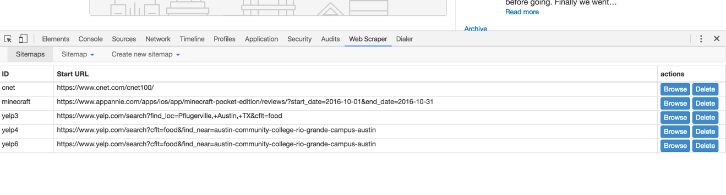

If you are opening it for the first time you will not be able to see any sitemaps. It will be completely empty.

## **Demo with Yelp**

Click on the “Create new sitemap” and select “create sitemap”, a window will then be displayed as follows:

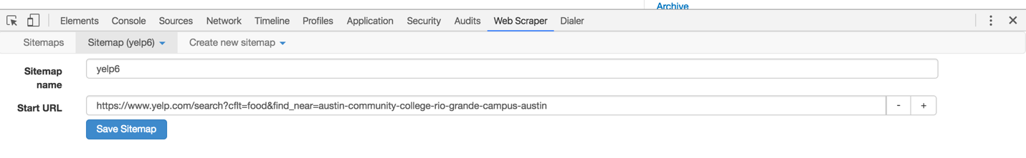

Provide a sitemap name and specify the URL(web address) of the initial page. This is the page with a list of restaurants. It is considered as a root or the starting point of navigation. Save the sitemap after providing the information.

Once you have saved the sitemap, an empty window with a button to add new selector will be displayed as follows:

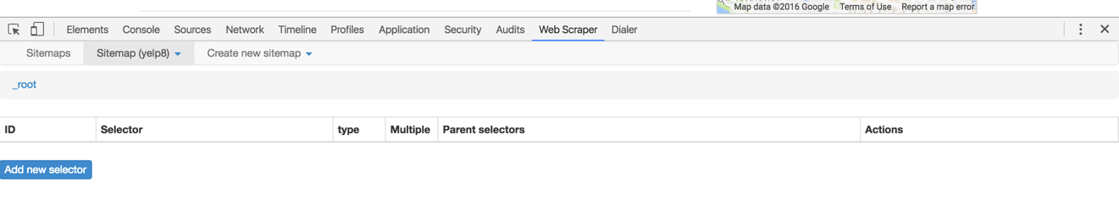

Click on the button to specify the action that you wish to perform on the root page. A window with various options is displayed as below:

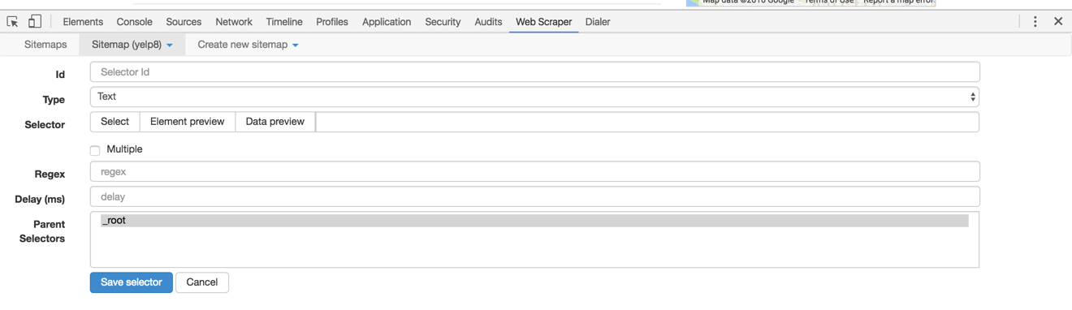

Id: provide a unique name to the action that you wish to perform. Any variable name can be given.

Type: Type specifies what kind of action you want to do. There are various possibilities:

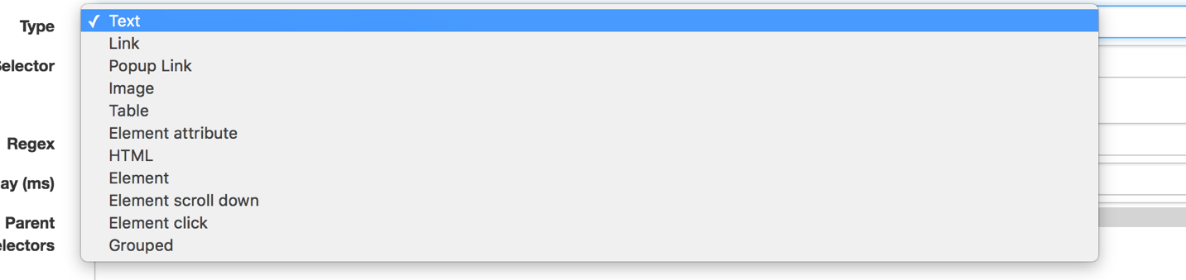

Text, Image: to extract the text and image.

Link: helpful in navigating the pages

Popup Link: helpful in dealing with the popup windows which show up when click is performed.

Element: helpful in playing around the divisions. Extremely useful in case of forum websites where all the reviews are similarly organized.

For the purpose of this demo, I would only use Element, Text, and Link types. Complete list of various uses of each element is present in the following link: <http://webscraper.io/documentation>

Since the idea is to scrape the reviews of good chunk of food places in a particular location, I have manually selected the location and the business type. Then I provided the link of that page as a root. My root webpage is the following:

<https://www.yelp.com/search?cflt=food&find_near=austin-community-college-rio-grande-campus-austin>

I want the scraper to visit the review page of each food business that has been listed and get the review text and demographic information of the reviewers. In order to do that we need to select the links of all the restaurants on the page.

## Selecting the Restaurant Links:

Select the sitemap that you have just created and click on the “add selector” button.

1. Give an “Id” of your choice.
2. Select the “Link” from types.
3. Check the multiple option (as we wish to get multiple links of restaurants)
4. Delay can be left empty.
5. Click on the “select” button in the selector bar. Now you will be able to mark the links on the web page. On the web page click on at least two restaurant links. It will automatically select the links of all the other links present in the page.

The web page with selected links looks as follows:

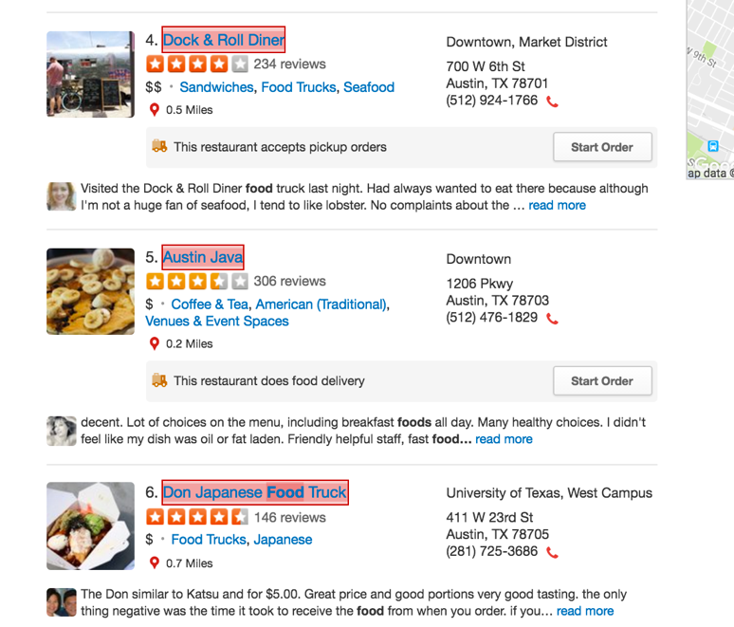

Once you have selected all restaurant links. Click on the done selecting button.

The selector view of the web-scraper looks as follows:

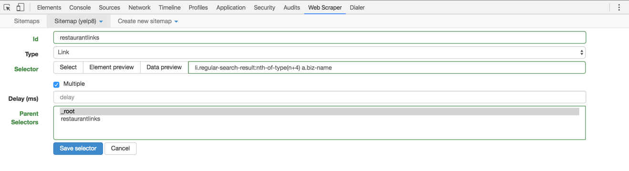

Click on the “Data preview” button to make sure that the tool has selected all the restaurant links. You will be able to see a pop up similar to this:

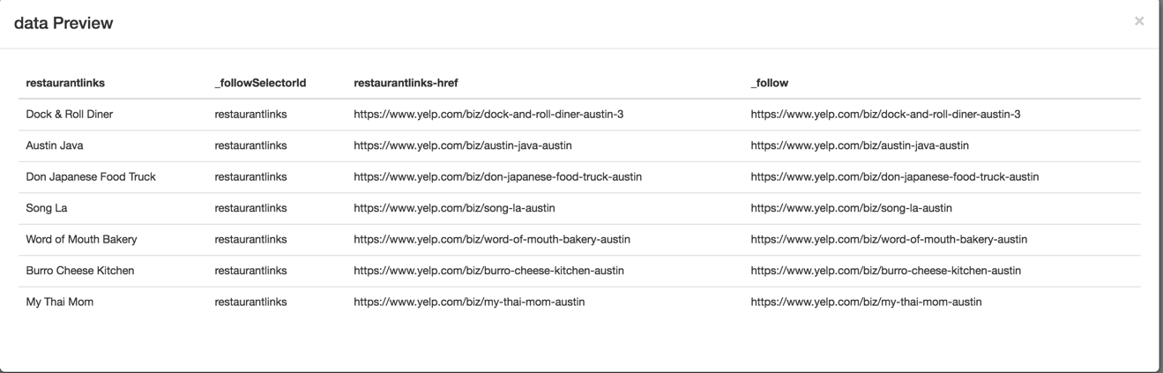

You can now close the pop and save the selector.

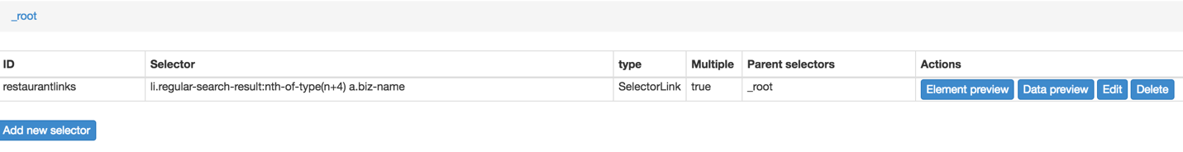

## Selecting the review elements:

This sections helps you to perform actions on the each of the links that you have just created. Within the web-scraper view, click on the “restaurantlinks” selector that you have created and go to a restaurant page in yelp.

Within the web-scraper:

1. Click on the “Add Selector” button.
2. Fill in the “Id” with some name
3. Select the “Element” as type as each review from a user is displayed in a similar “div” tag.
4. Check “multiple” box as we have to select reviews of multiple user
5. Click on the “select” button and select at least two divisions of reviews with in the review page. The selected web page looks as follows:

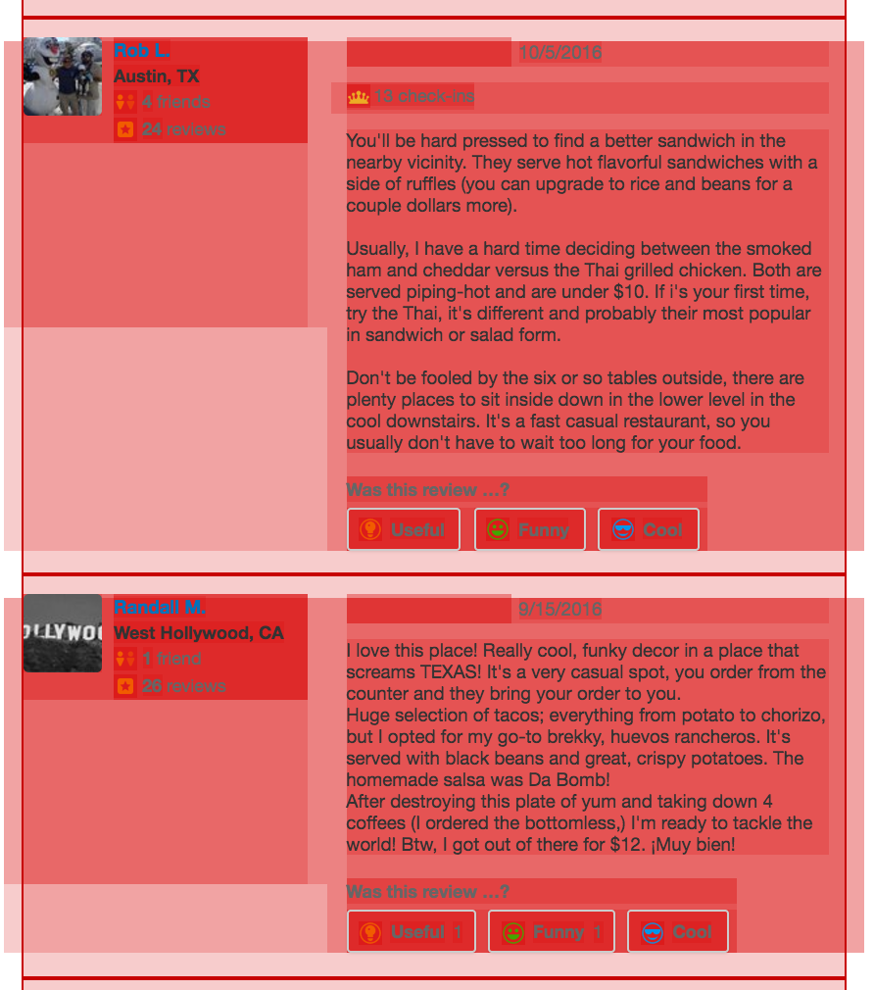

When you have selected the divisions of reviews. You can save the selection. The selector with in the web-scraper looks as below.

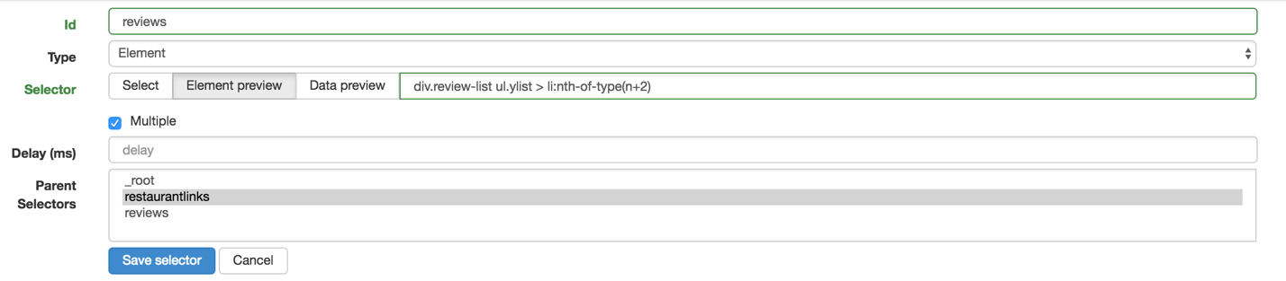

You can now save the selector.

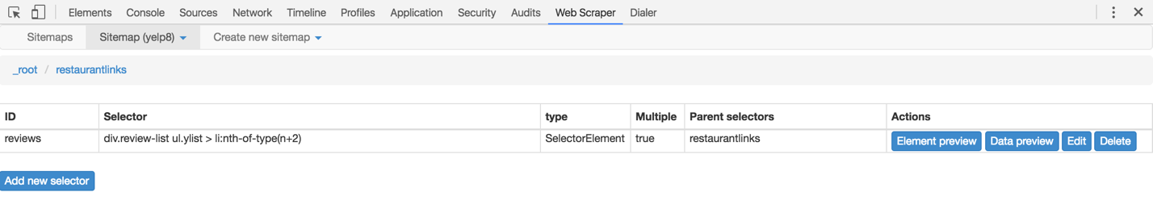

## Selecting the Review Text and User information:

You can now select the parts of the “review element” that you want to extract. Click on the “reviews” element that you have just created and click on the “add new selector” button.

Selecting review text:

1. Fill in the Id
2. Select “text” as Type
3. Click on Multiple
4. Click on “select”. A part of the review element gets highlighted on the web page. Within this highlighted portion, select the review text. The selected portion of the webpage looks as follows:

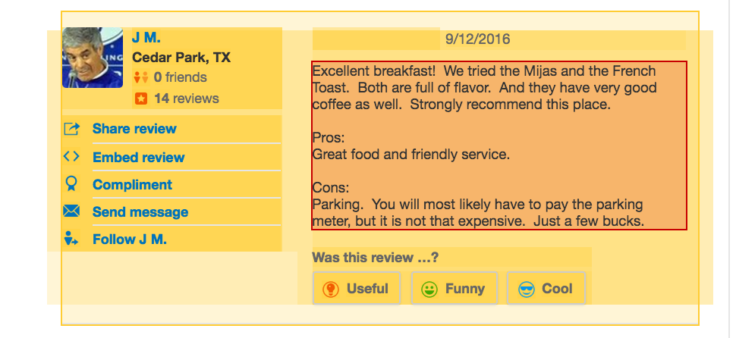

Once you have selected the text. Save the selection by clicking on “Done selecting”. Click on “Data Preview” to preview the review text the tool has selected. You will be able to see a pop as follows:

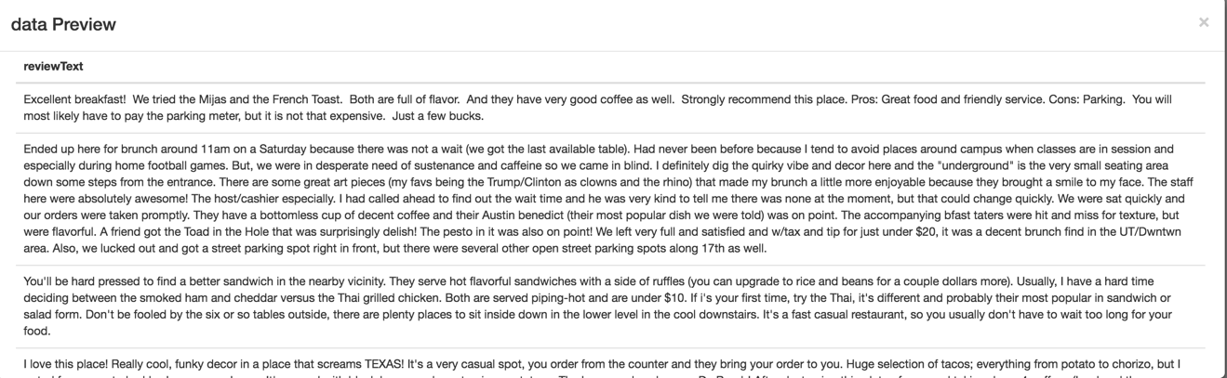

You can now close the preview and save the selector.

Similarly, you can select the name of the user, date of the review, etc.

At this stage you can look at the site map of the scraper, to confirm all the steps that you have added to the tool. The site map looks as follows:

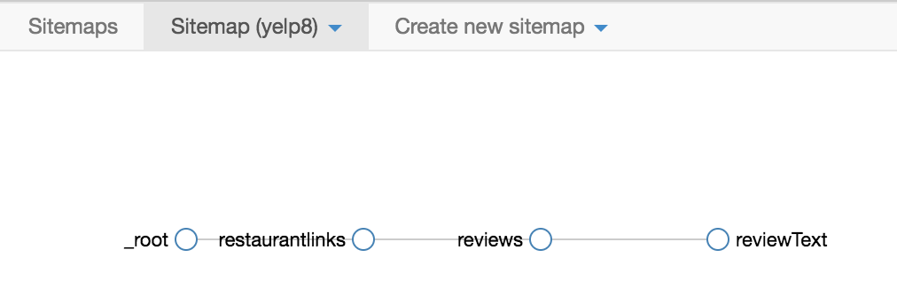

You can now go ahead and pagination to the reviews.

## Pagination to the reviews:

Each restaurant has at least two pages of reviews. So far, we have only enabled the functionality to scrape the reviews from the first or default display page. In this step, we will enable the web-scraper to scrape the reviews from other pages as well. However, the idea is very simple. We will add the links of other pages and make the review element (which can get the review text) as a child of this node.

Click on the “selectors” from the “sitemap” and go to the “restaurantlinks” selector to enable pagination.

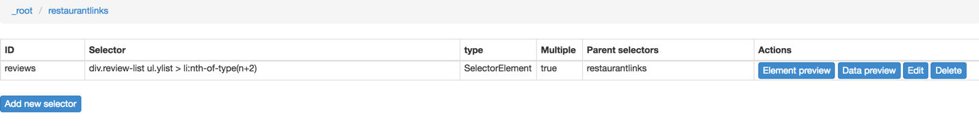

Click on the “Add new selector” button.

1. Fill in Id with some name like “reviewpages”
2. Select “Links” from Types
3. Check the “multiple” option
4. Click on selector and select the page numbers which have the link to navigate to the next page.

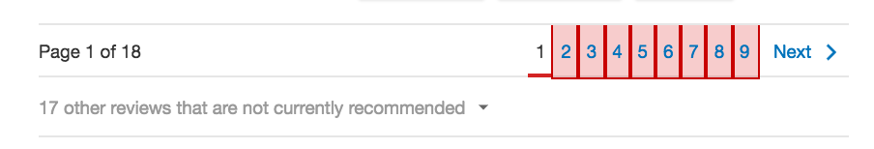

Once you are done with selecting the links, save the selection and the “reviewpages” selector.

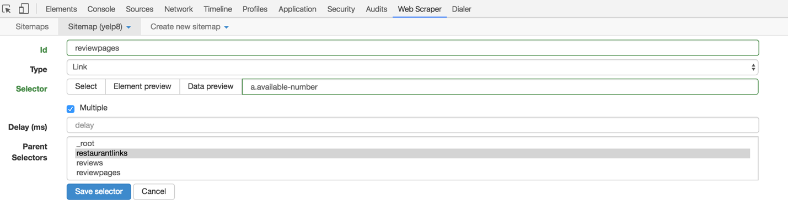

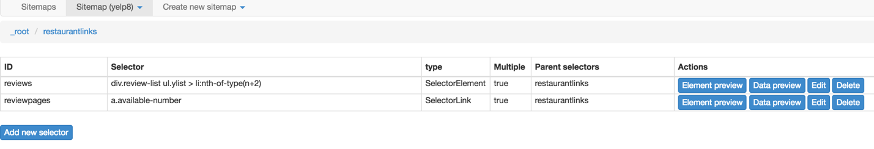

We will now make the “reviews” selector child of the “reviewpages” selector.

1. Click on the edit button of the reviews selector.
2. Select reviewpages from the “Parent Selectors” and save.

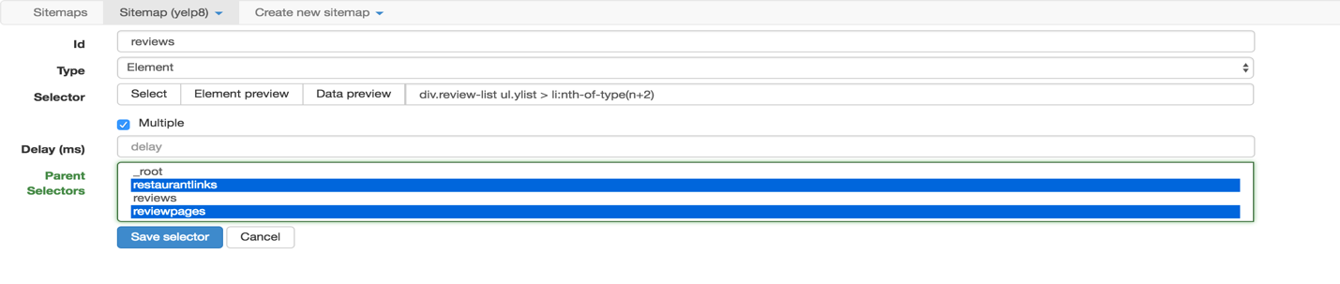

we can now view the “selector graph” to make sure the steps in navigation. The selector graph looks as follows:

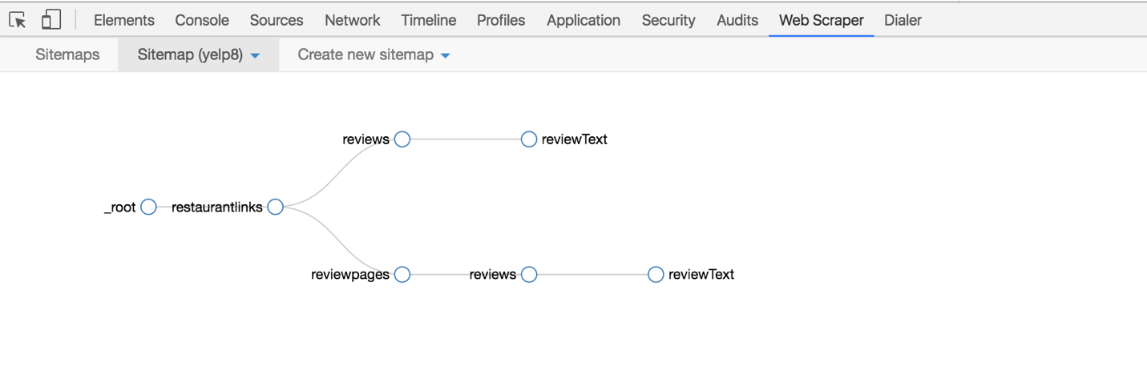

## Pagination of Restaurant Links:

In this section, we will try to scrape the reviews of restaurants listed in pages 2-9. The idea is similar to the pagination that we have done for reviews. Click on the selectors and go to the root selector in the web-scraper.

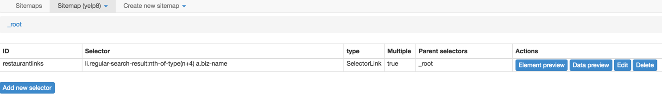

To add pagination to the restaurant links:

1. Click on the “Add new selector” button.
2. Fill in the box for “Id” with something like- “restaurantpages”
3. Select “Links” from the Type
4. Check the “multiple” box.
5. Click on the select button and select the pages that you want to navigate.

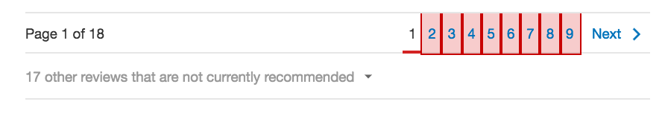

1. When you are done selecting, save the selection and the selector.

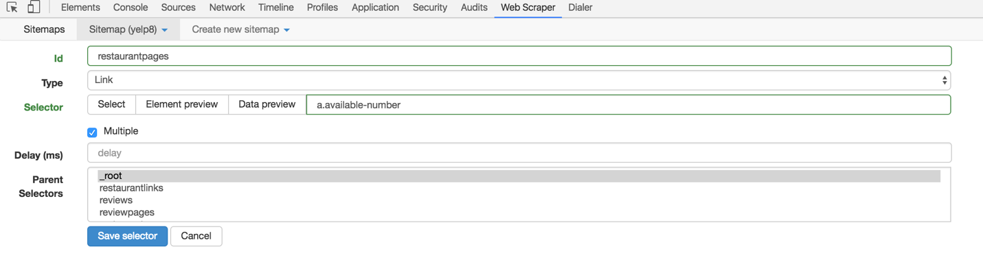

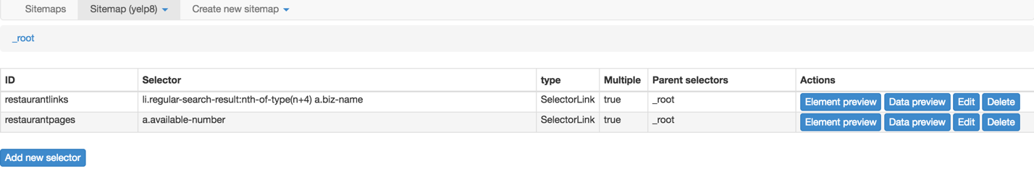

1. Now click on the edit button of the “restaurantlinks” selector and select “restaurantpages” from the parent selectors.

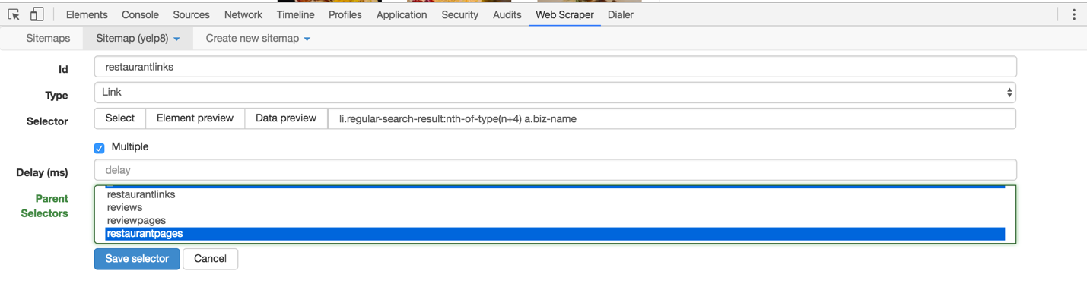

You can now save the selector. Once again to check the stages of scraping, we will go ahead and look at the selector graph.

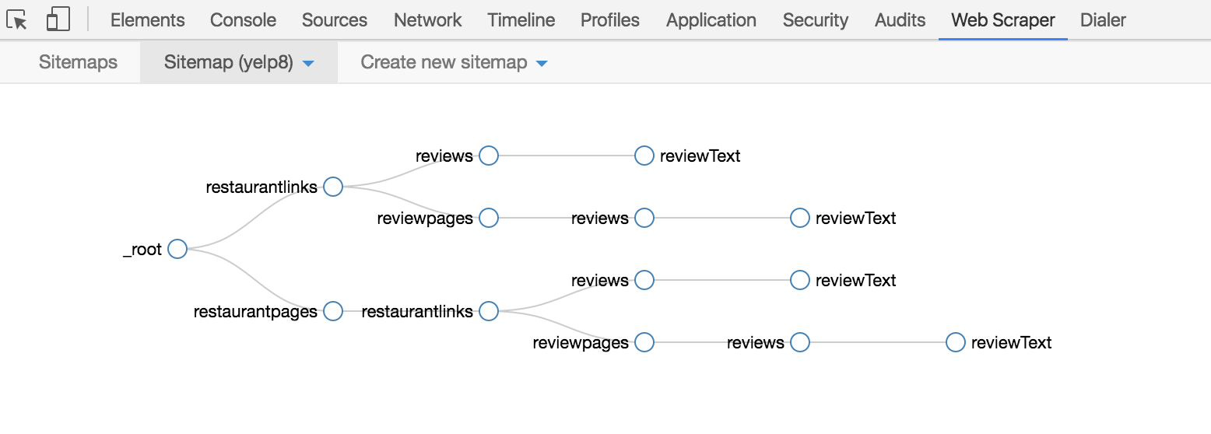

Once you have the above graph, you can now start scraping by selecting scrape option and wait for it to finish. You can leave the delays as default and start scrapping.

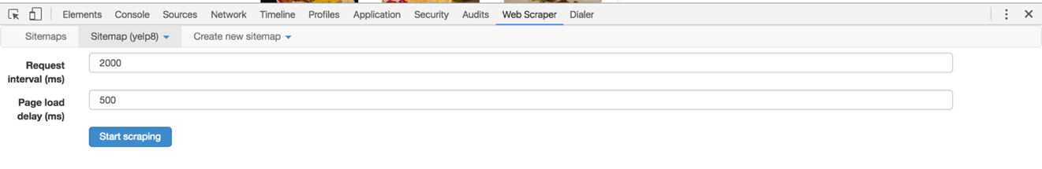

Once the scraping is finished. You can export the csv by selecting the “export csv”. You can directly download the csv file by clicking on the “Download now!” link.

**5. Unsupervised Sentiment Analysis with SentiStrength**

SentiStrength works without training data, but is not particularly smart about calculating sentiments (as it simply adds weights of individual words to produce a positive and a negative score for each message). Its main advantage is that it works without training data and gives one positive and one negative score per post or message.

Download the (i) dictionaries and (ii) software from <http://sentistrength.wlv.ac.uk/download.html>. When you run SentiStrength it may ask you where the data files are located. Once you specify this location, you are all set.

To get a clean, easily readable output, I suggest you uncheck “Report Classification Rationale” and “Report Translation” under “Reporting Options”. Do this before you ask SentiStrength to analyze the social mentions.

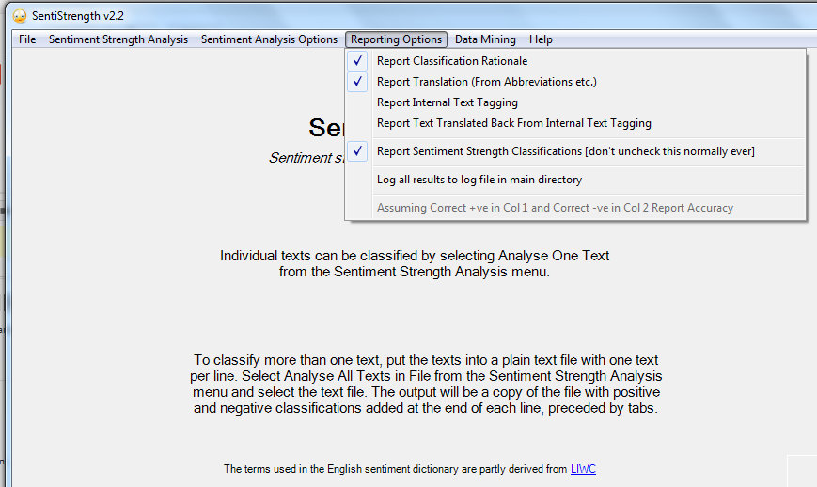

After unchecking the options.

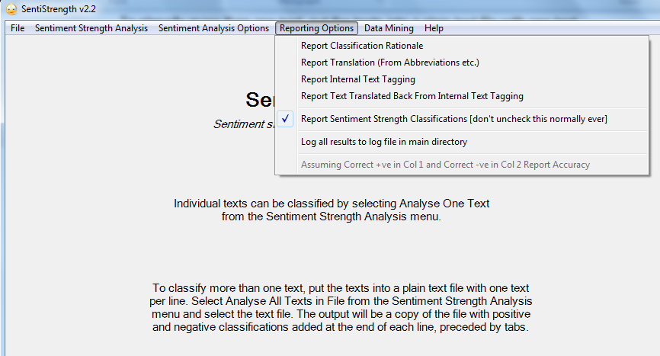

Also you may want to delete the first row in the CSV file containing the text – this row contains the headers.

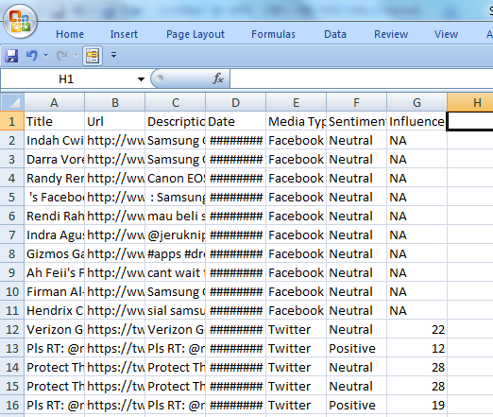

Save the CSV file as a tab delimited text file in Excel. Now choose “Amalyze ALL Texts in File” under Sentiment Strength Analysis in SentiStrength.

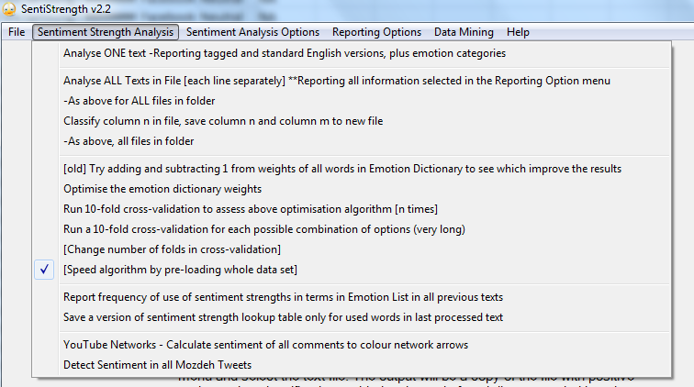

Choose the text file you created and SentiStrength asks you which column contains the text (in most cases the response will be “1”)

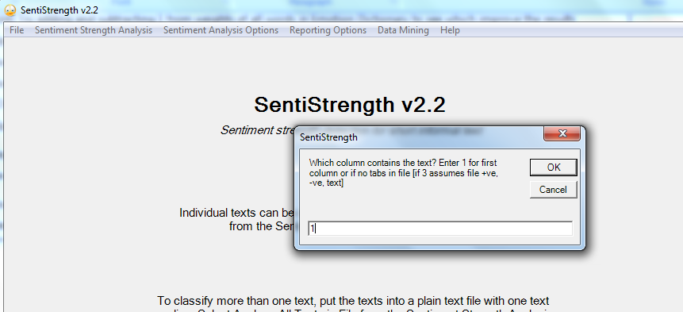

SentiStrength adds “+ Results” to the name for the output file. Also make sure that the original file with the mentions has been shut down by Excel (otherwise SentiStrength will not work).

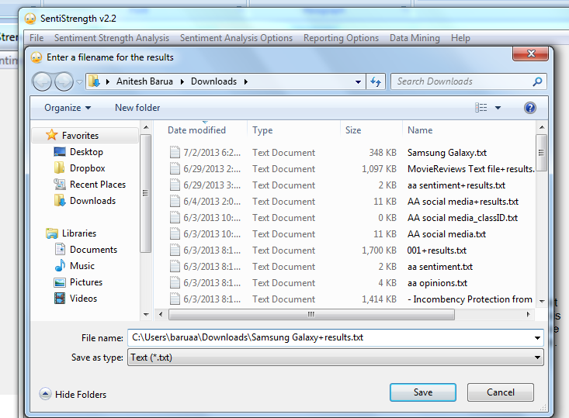

SentiStrength is quick in doing its job. Now open the output file with Excel, which should recognize the tab delimited nature of the output file. It takes you through a bunch of steps (just agree and continue clicking on “next” until you see “finish”) as shown below before opening the file with a clean output.

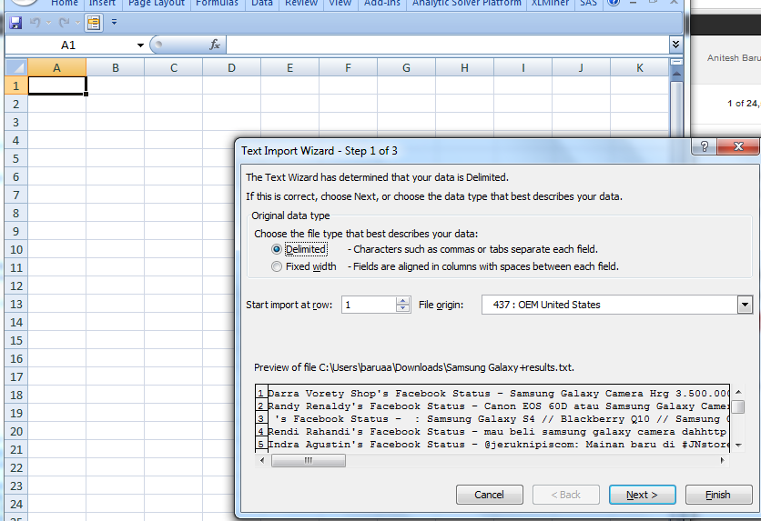

Generally just clicking on Finish above should produce a clean output. If not, continue as shown below:

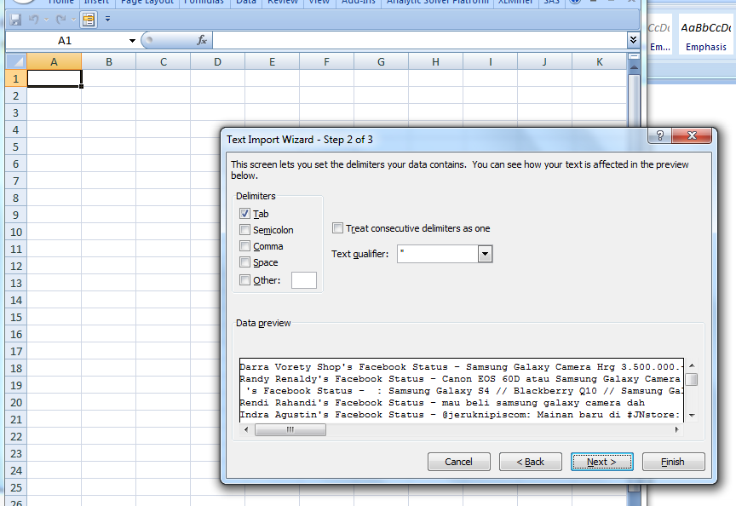

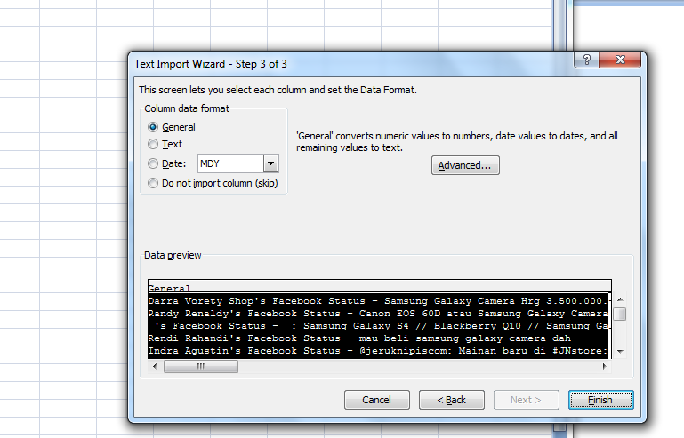

SentiStrength creates two columns (H and I in the screenshot below). It inserts a positive sentiment in the first column and a negative in the latter. The sum would be the net sentiment. Note that the Trackur sentiment in column F matches the SentiStrength sentiment reasonably well (at least in this case).

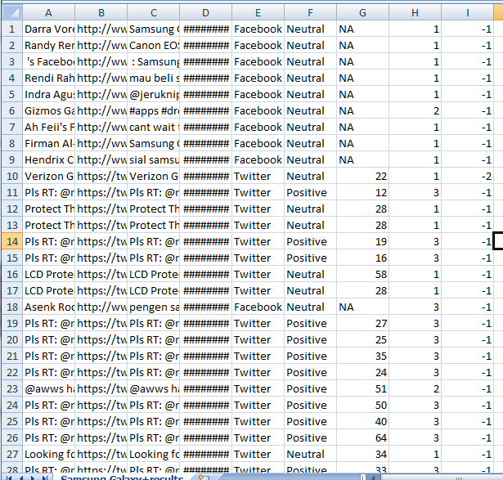

Now after some spot checks if you want to tweak the weights of individual words to improve the sentiment analysis of SentiStrength, I recommend that you check “Report Classification Rationale” under “Reporting Options” (you had unchecked this option earlier to get a clean output). Now run the analysis again, and this time there will be an extra column created by SentiStrength which shows how it calculated the sentiment from weights of individual words. I have attached the file where this rationale is shown in column J. The word weights used are shown, and if you think (after spot checks) that some words should have different weights from the defaults used by SentiStrength, you can change them in the EmotionLookup text file you downloaded when installing the software (see below).

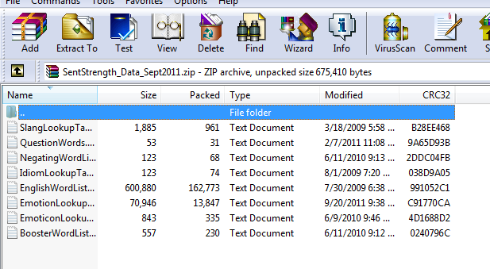

You can manually change the weights in the first EmotionLookup file. If you do so, make sure you reload the file into SentiStrength. You can do this by choosing “Reload all lookup tables used in emotion classification” under the File menu in SentiStrength.

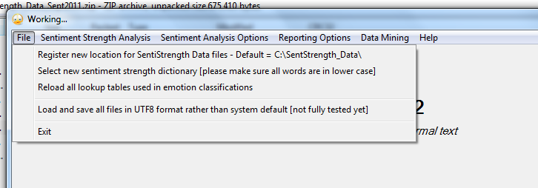

I haven’t had the time to try this out, but you should be able to add new words as well. To do so, you will have to add new words in the EnglishWordList file (in the same directory as the EmotionLookup file), and then add the words along with sentiment weights in the EmotionLookup file. Don’t forget to tell SentiStrength to reload these lookup files before doing any analysis. For more information, go to the website:

<http://sentistrength.wlv.ac.uk/>

**SentiStrength for Mac Users**

Please download the Java version from here:

<http://sentistrength.wlv.ac.uk/SentiStrengthCom.jar> (please copy and paste rather than clicking the link)

and use it with the text files extracted from this zip file

<http://sentistrength.wlv.ac.uk/SentStrength_Data_Sept2011.zip>

There is a brief manual online.

<http://sentistrength.wlv.ac.uk/documentation/SentiStrengthJavaManual.doc>

There is a bit of extra information for the Java version on the web site too. This is for academic use only.

**6. Network Analysis with NodeXL**

Install NodeXL from <http://nodexl.codeplex.com/>

After installation, you need to start NodeXL separately from Excel:

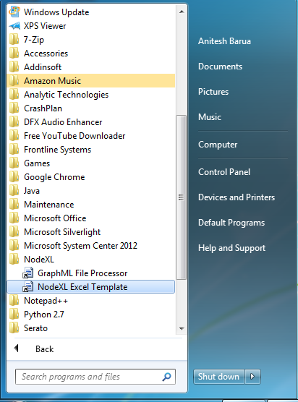

which opens NodeXL in Excel. Assuming you have calculated lift values between pairs of brands, you should manually input the brand pairs and the lift values in a column which should be labeled “Lift.” (see screenshots below):

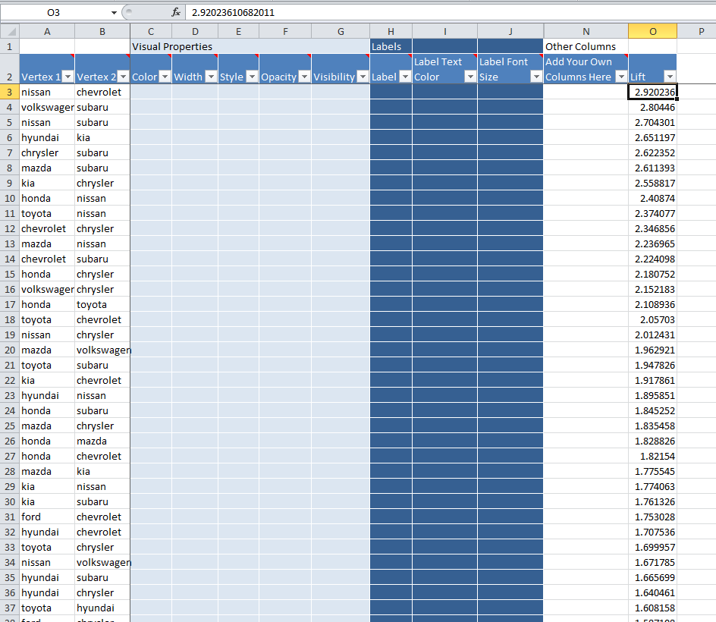

NodeXL has two worksheets: Edges (links) and vertices (or nodes). In the vertices view you should see all the brands (you don’t have to type them in; once you enter them as pairs in the Edges sheet, NodeXL should pick up the brands automatically, though it may take a bit of time. You want to label the nodes with the names of the brands. In the Vertices sheet, reformat the Label cells to “General”, and follow the screenshots.

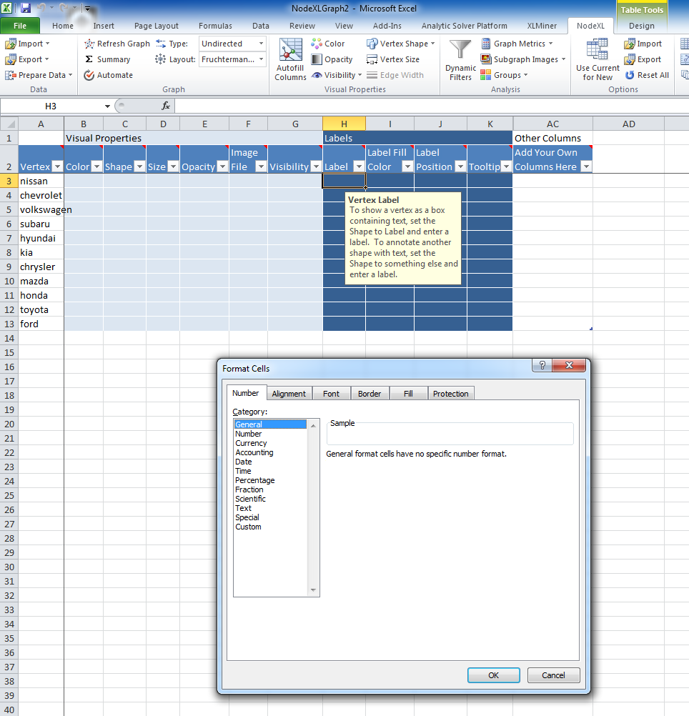

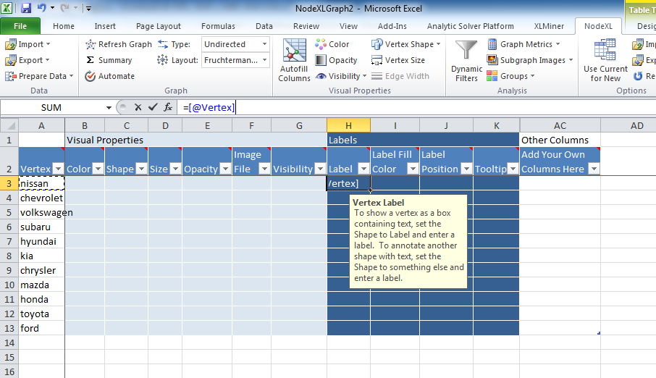

At this point, let us take a look at the network of brands. To do so, click on **Refresh Graph** as shown below. You can click on **Lay Out Again** to change the way the network looks.

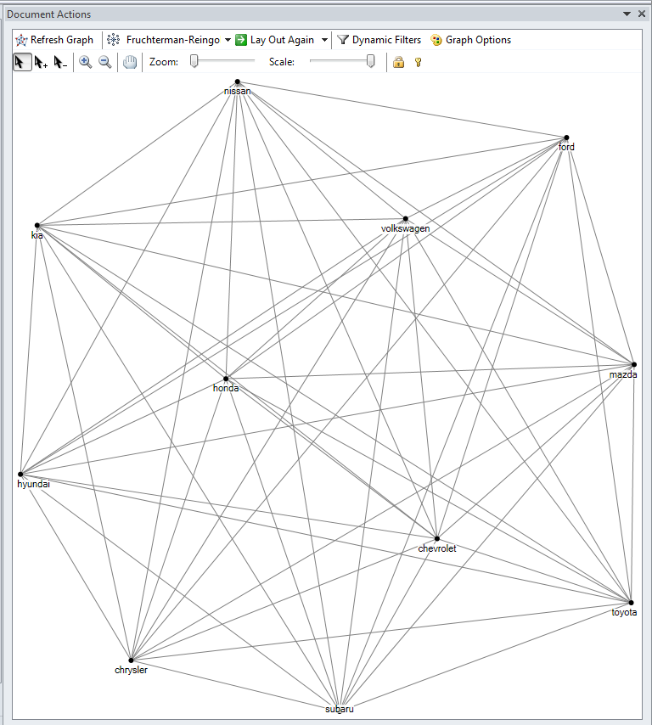

Note that this is a fully connected network (or pretty close to it), where every brand is connected to every other brand. That is not very useful, for we are interested in “strong” associations between brands. How strong is strong is subjective, but for illustration, we will choose a lift value of 2 as the threshold (you may have to experiment a little in your case). So basically we are going to use a cutoff value of lift to make the network less dense. The easiest way to do this is to use the **Autofill** feature of NodeXL – see screenshots below:

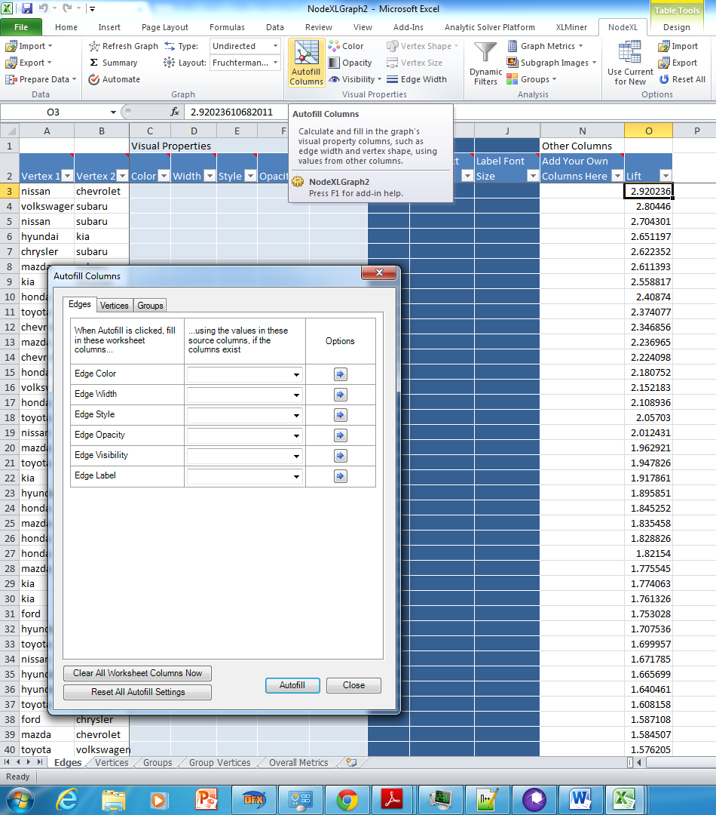

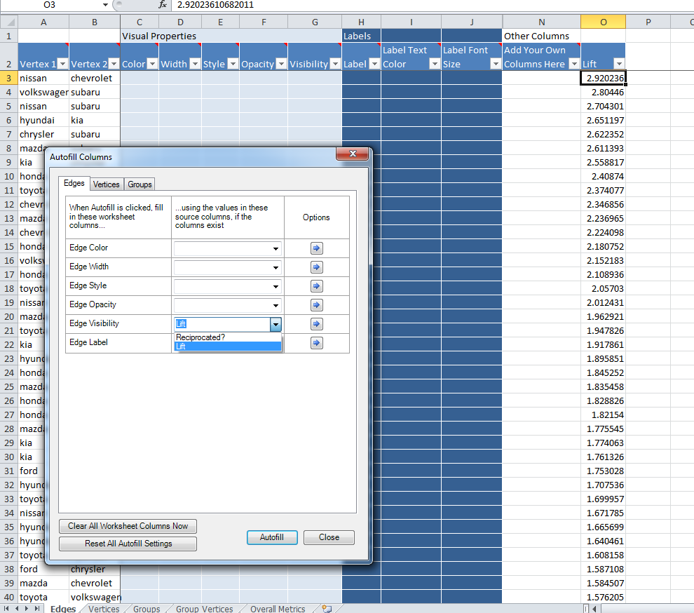

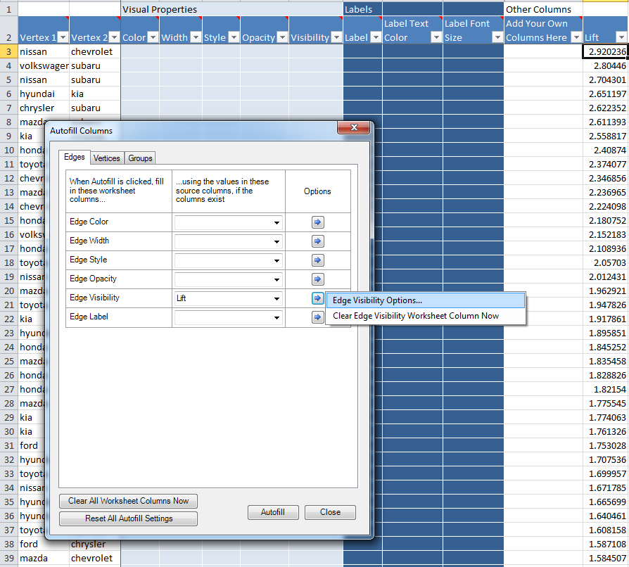

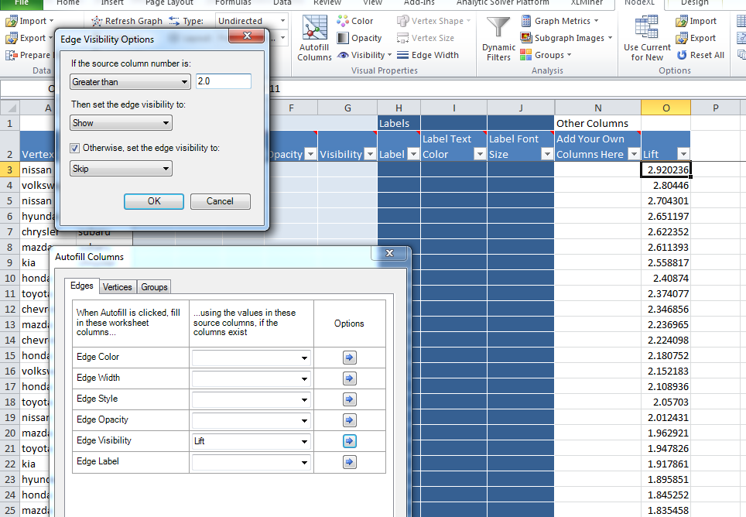

Under options for Edge Visbility, we set the threshold to 2, and click OK and then on **Autofill**. You should see a new network that is considerably sparse (see below).

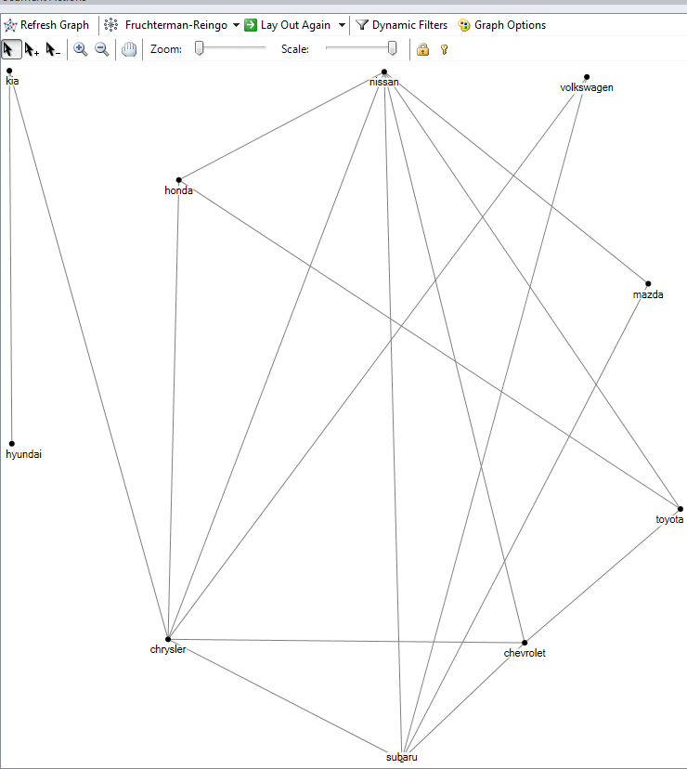

However, to tease out insights from his type of network analysis, let us calculate some metrics – degree, betweenness and closeness. To do so, use the **Graph Metrics** function of NodeXL as shown in the screenshots below:

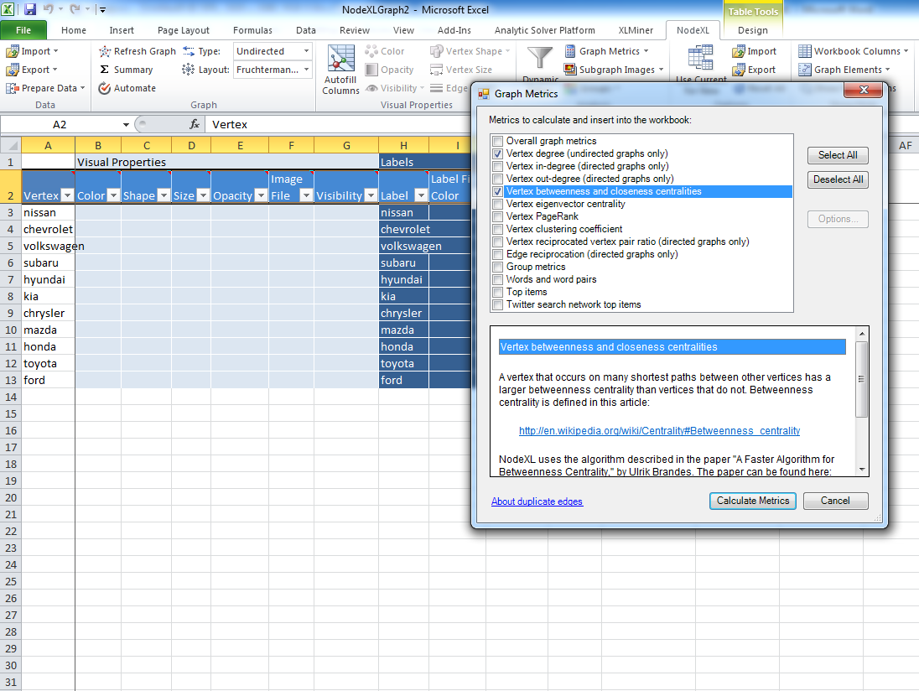

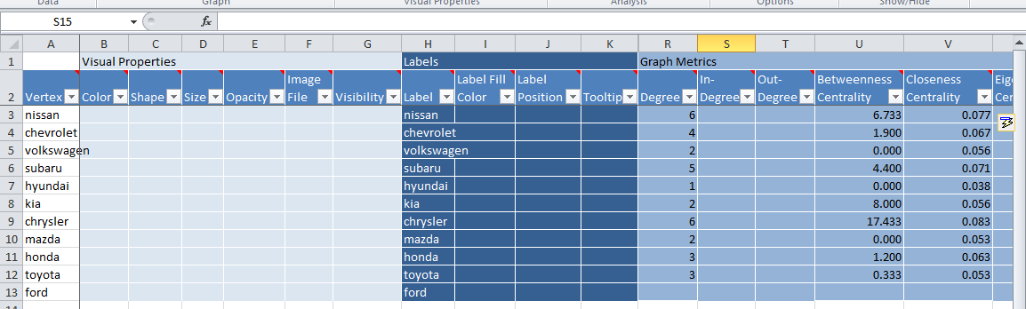

Now let us get back to Autofill and change the way the network looks even more. Let’s use the Vertex view and change the size of the vertices based on degree. Note that I changed the max size to 30 (the default was 10; you have to do some trial and error to see what offers a good representation)

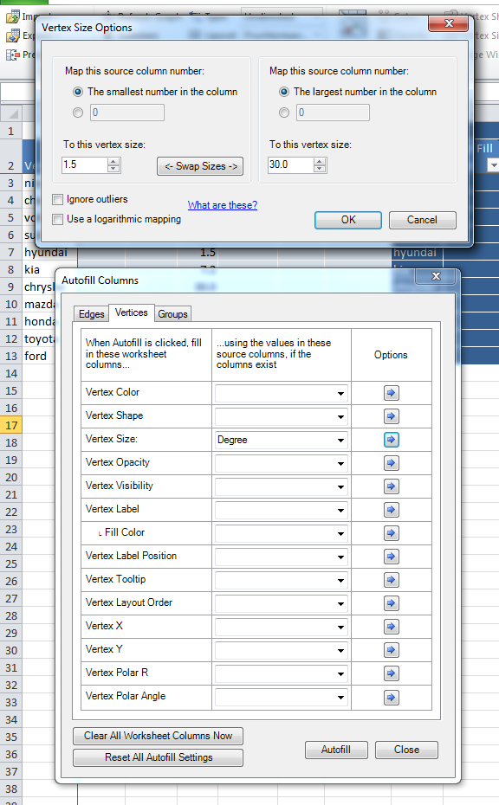

Then I set the Opacity of the vertices to Betweenness Centrality, and the Width of the Edges to Lift values. The resulting network is shown below:

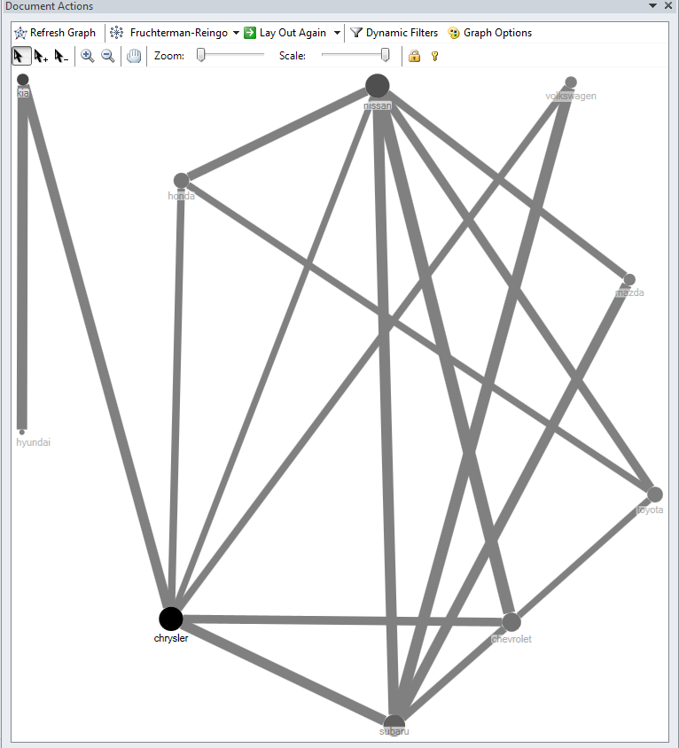

Now I can see which brand is compared to most others, which is being compared with different types of cars, and which associations are strongest.

**7. Multi-Dimensional Scaling (MDS) with XLStat**

I will use a data file (posted on Blackboard) called **proximity matrix example**. Install XLStat from xlstat.com. As in the case of NodeXL, you can start XLStat by clicking on the icon from your programs, or you can also start from Add In inside Excel.

To do MDS, first create a lift matrix and a dissimilarity matrix (where each entry = 1/lift) as shown below:

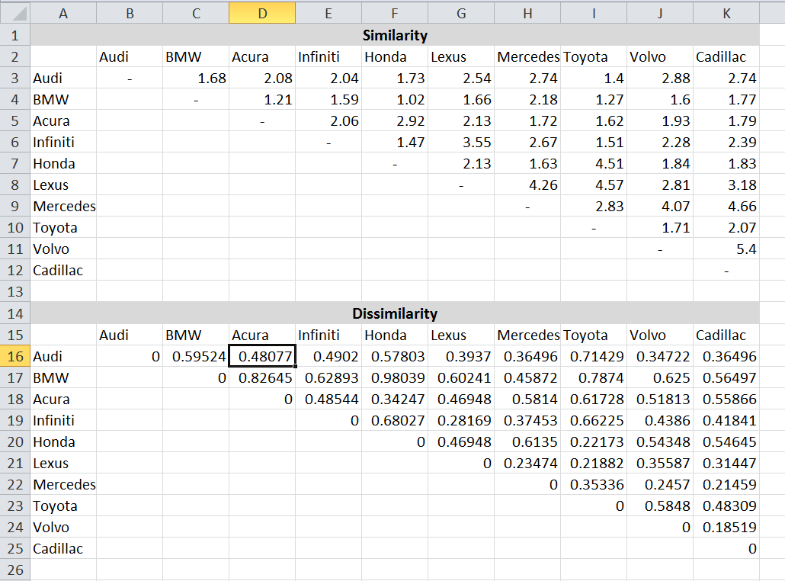

Now use the MDS function of XLStat as follows:

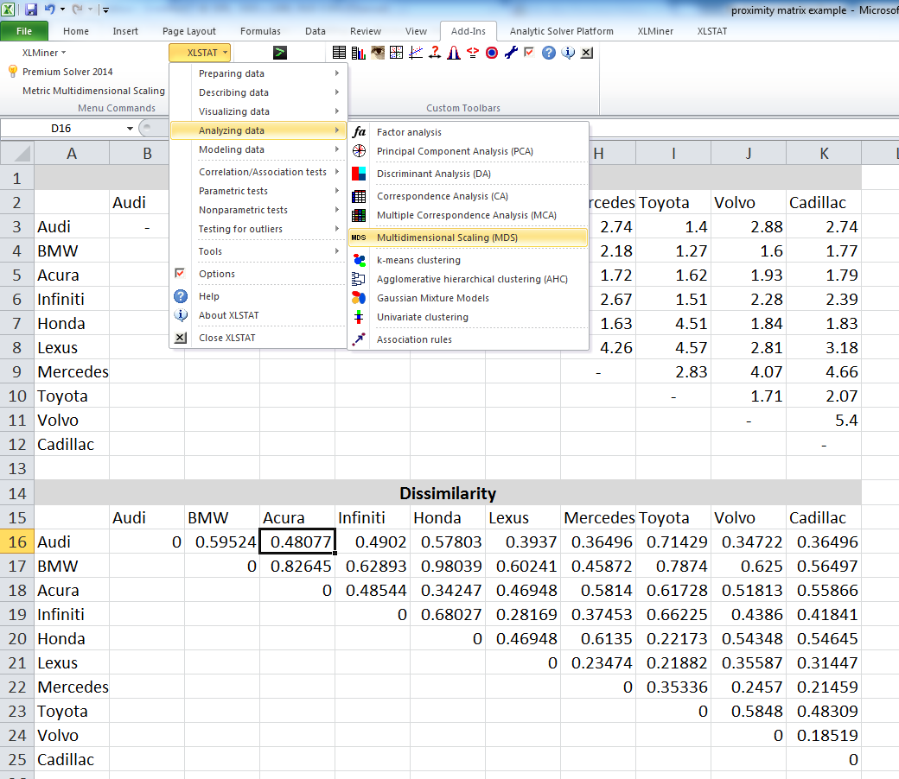

Specify the dissimilarity matrix to XLStat (include the labels) as shown below:

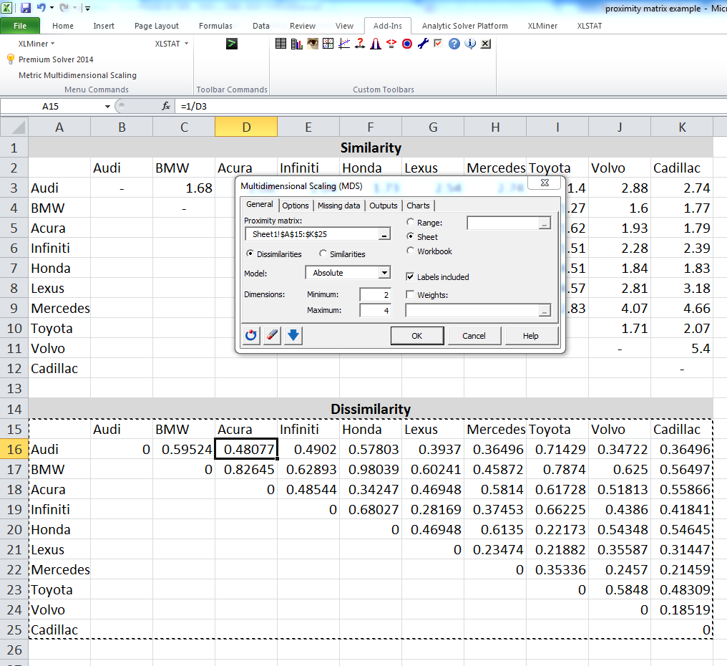

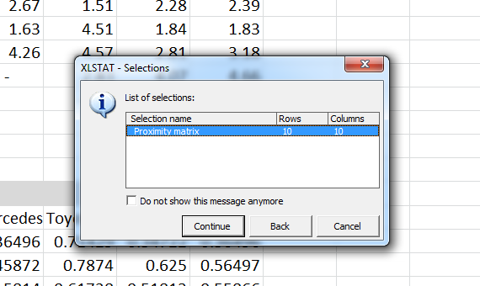

Hit Continue, and you should get a long output, from which we get the MDS map:

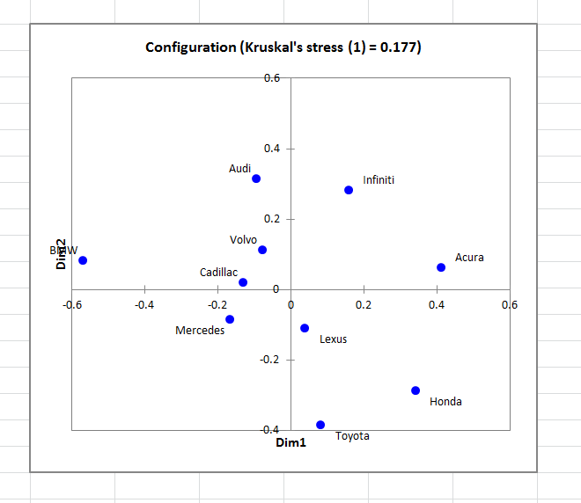

**8. Network Analysis with Gephi (Free alternative to NodeXL)**

Install Gephi from <https://gephi.org/users/download/>

After installation, open Gephi and select new project: You can still go ahead and complete the visualization even when you don’t understand the side note.

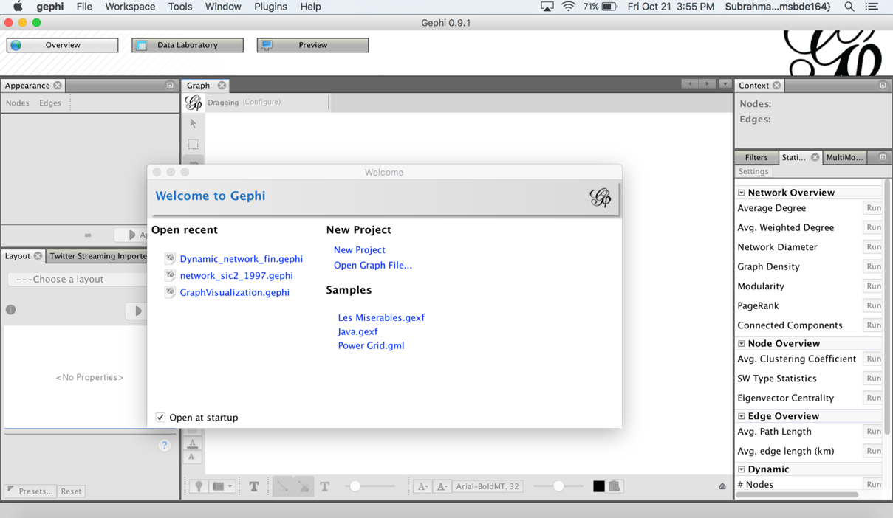

Once you click on the new project option, a blank screen will appear as shown in the picture below.

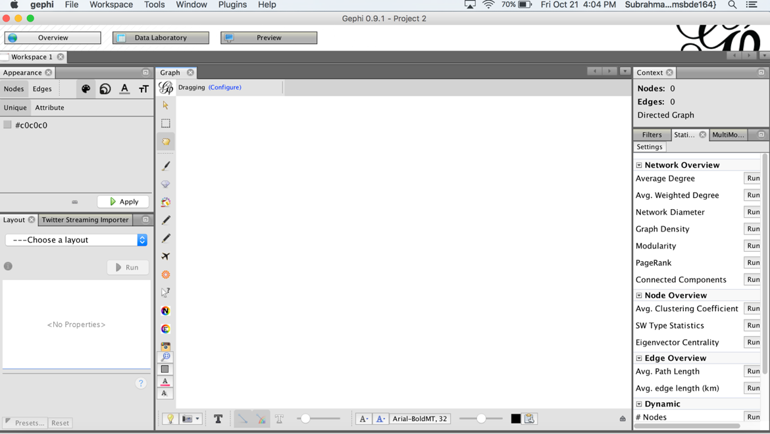

Gephi has three major tabs: Overview, Data Laboratory, and preview. In overview tab, we can play around various layouts, adjusting the size, color, and label of the nodes(vertices) and vertices. Data table has the features of importing and exporting, filtering, etc. Preview tab is to preview the graph before exporting the visualization you have made. All the three tabs are visible on the top.

Assuming, you have the edges table ready in a csv file. Gephi is sensitive to the names of the columns in your csv file. Indicate the “source” and “target” vertices or nodes (see screenshots below). In your case, vertices might be the names of the car models.

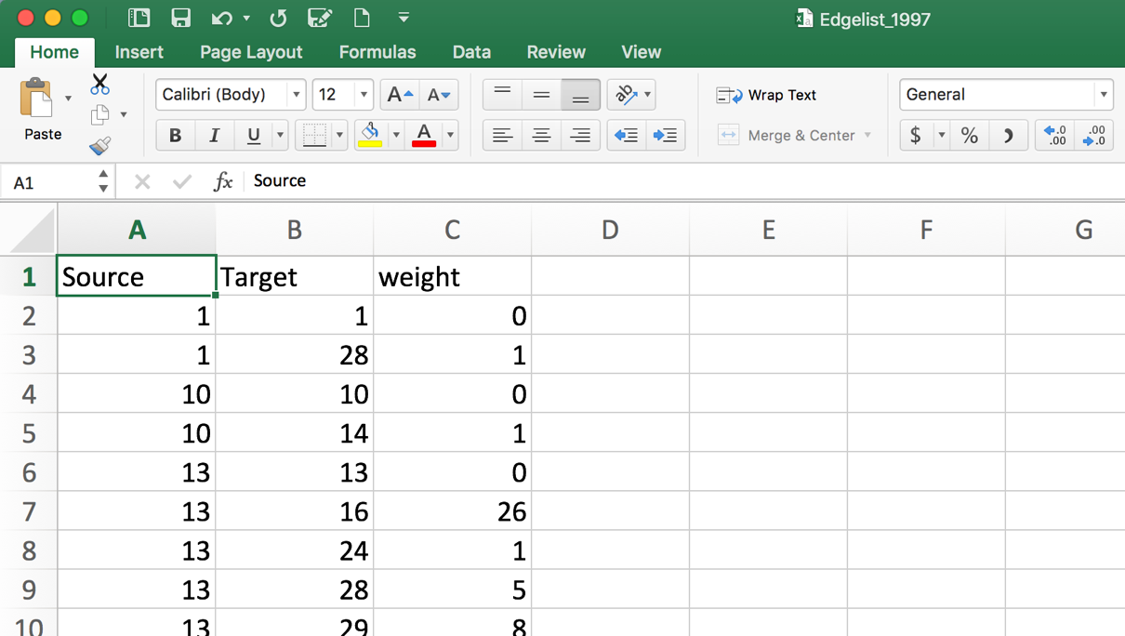

# Importing the Network:

Click on the Data laboratory button and then click on import Spreadsheet. A new window will now pop up with option to select the csv file that you want to import. After selecting the file, select the edges table. Check the preview, to make sure that the file is imported correctly (as shown below).

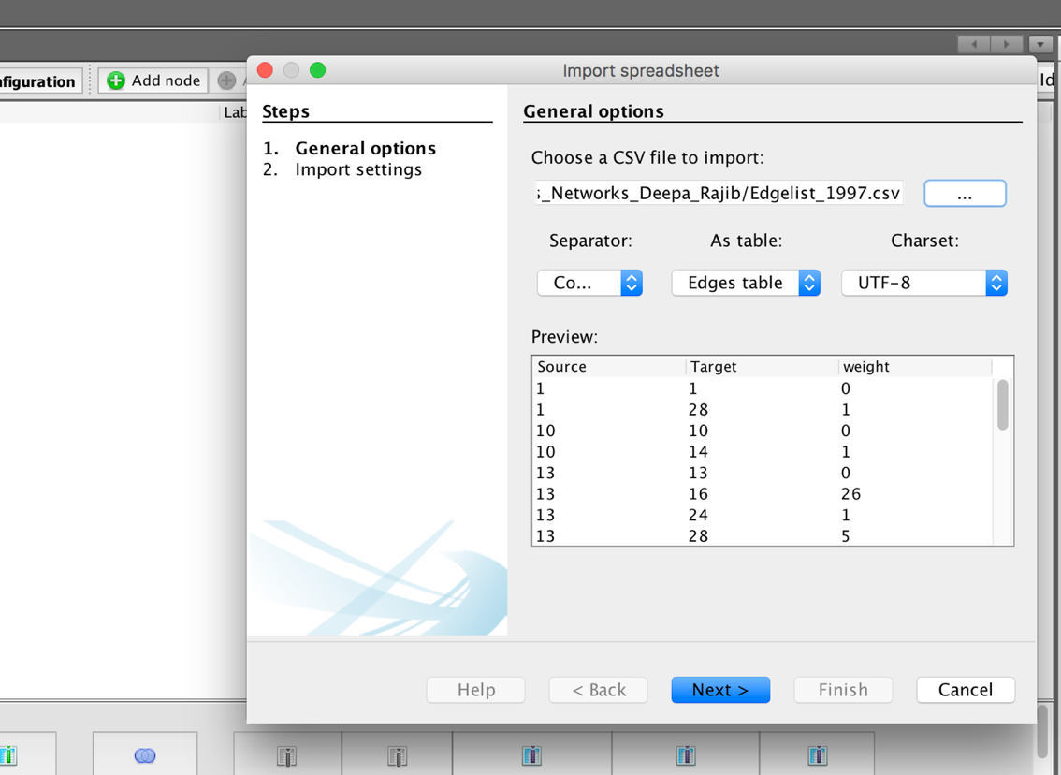

Click on the next button and then click on finish. You will now be able to see two tabs nodes and edges with in the data laboratory as shown in the pictures below. Gephi will automatically create a nodes table listing all the vertices under the column named as “Id”. Edges table will look similar to the excel file except that it would have a new column named Type. Type specifies the type of an edge either directed or indirected. Gephi by default considers the edge list as Directed unless specified otherwise.

Nodes table:

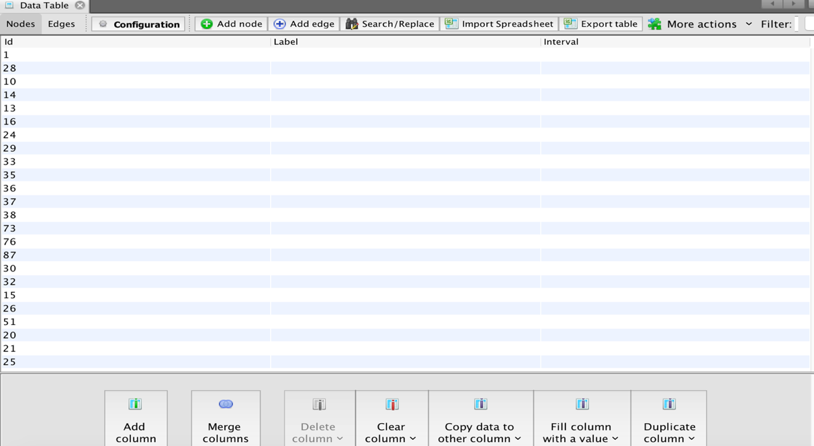

Edges Table:

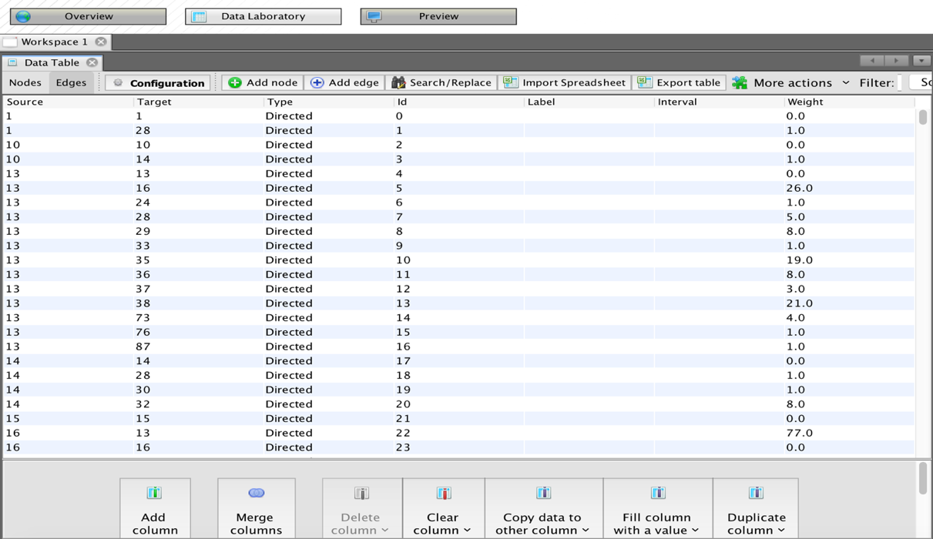

Now click on the overview button. A window with random layout of graph appears as shown below.

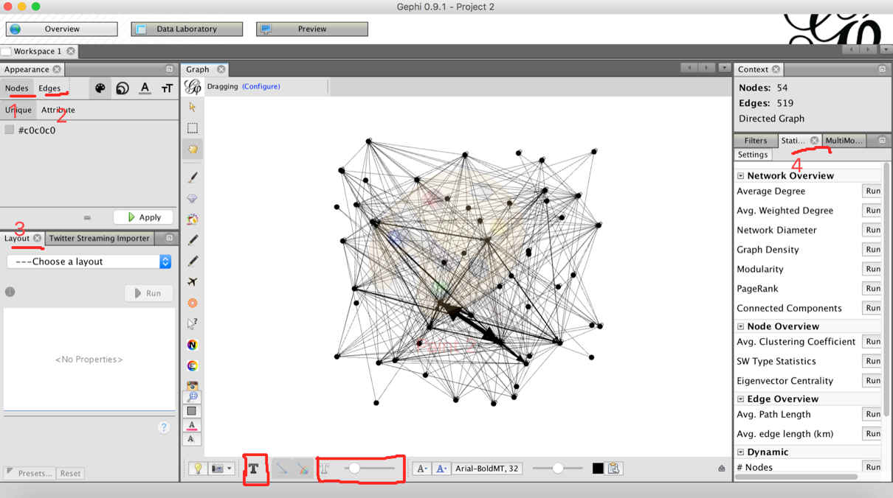

Please notice that there are various tabs embedded within the overview which will help you in changing the appearance of the graph or network. The main elements to be noted are marked in the above picture.

1. Nodes: Gephi helps in adjusting the node size, node color, label size and label color based on selected attribute.
2. Edges: You can manipulate the color of the edge, label size, and label colour of each edge based on edges’ attributes.
3. Layout: Gephi has wide variety of algorithms which adjust the appearance of the network based on various matrices like connectedness, size of the network, degree distribution etc.
4. Statistics: This feature will enable us to calculate various attributes of the node, edges and the overall network. Measure like Degree, Betweenness Centrality, PageRank, Closeness Centrality, etc are all calculated using this tab.
5. The node labelling and the scaling the width of an edge is done using the buttons present at the bottom of the page.

## Labelling the nodes:

Go to the Data laboratory. Click on the nodes tab. Then click on the “**Copy data to other column**” option present at the bottom. Select “**id**” from the list of options. A small window pops as shown in the screenshot below. Select “**label”** from the available options. Then click on OK. This will label each node with the name of the node mentioned in the edge list.

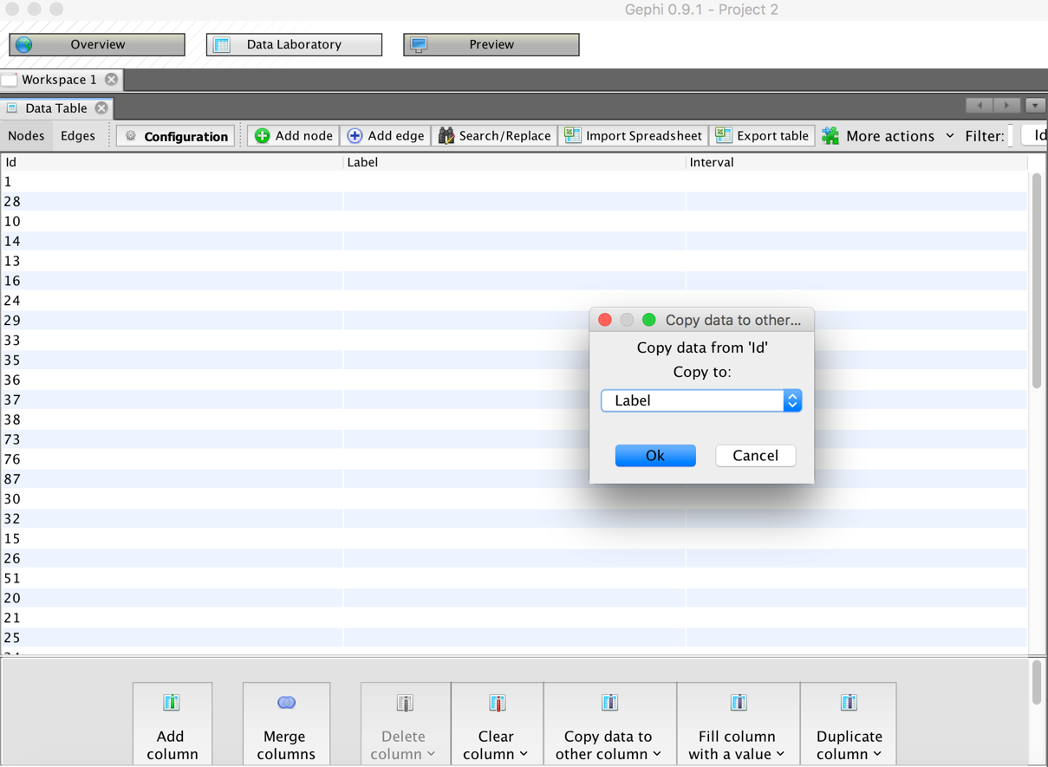

Once the labels are created, move on to the overview tab. Click on the bold **“T”** button present at the bottom (marked in the picture below). This will label your graph automatically.

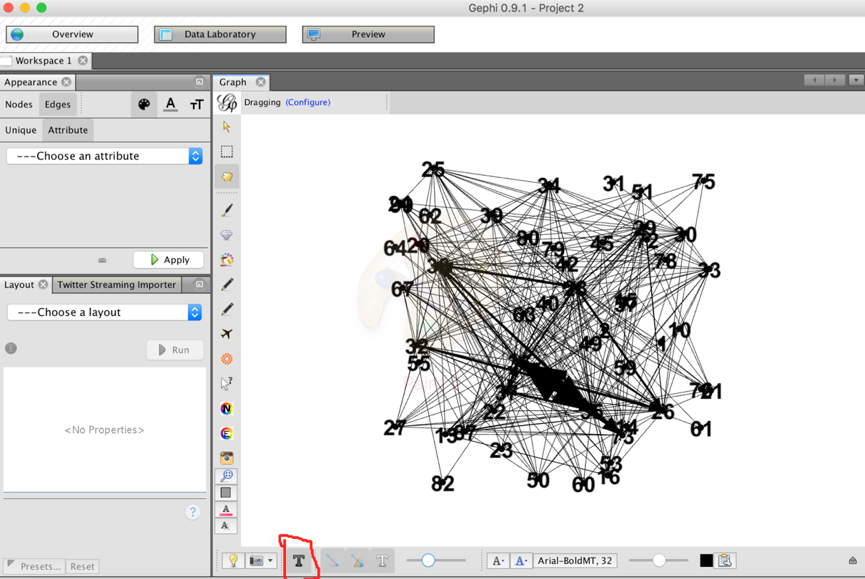

You can click on **“Choose a layout”** to change the way the network looks. Before going into visualization, calculate various graph metrics. “Statistics” tab present to the right of the overview page has a list of various plugins through which different network measures can be calculated.

### Degree:

In the statistics tab, run the “**Average degree**” plug in. This will open a new window with the display of graph specifying the distribution of indegree, outdegree, etc. You can close the tab and navigate to the data laboratory and verify if the degree (Indegree or Outdegree) is added to the nodes table. The screen shot of each stage is presented below:

1. Run the Average Degree plugin with in the statistics tab to the right:

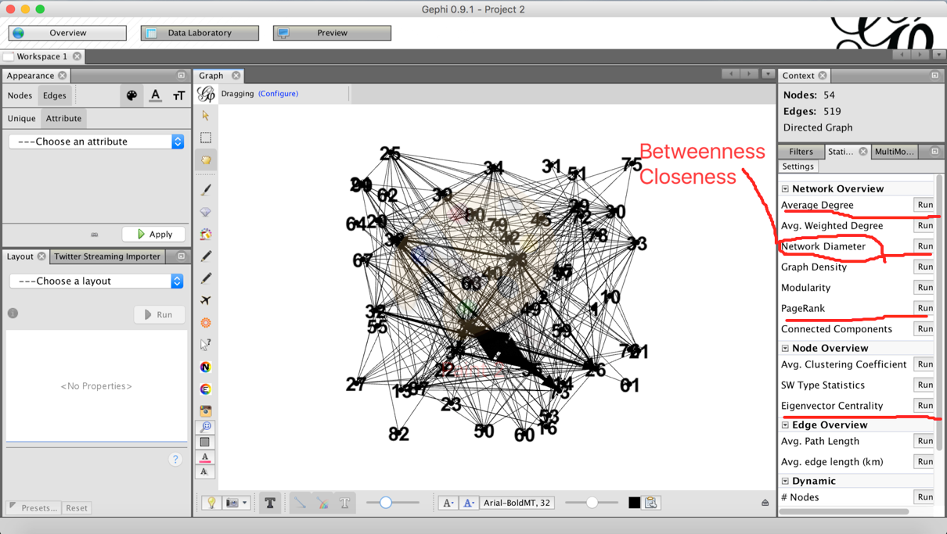

1. A window with degree report can be as follows:

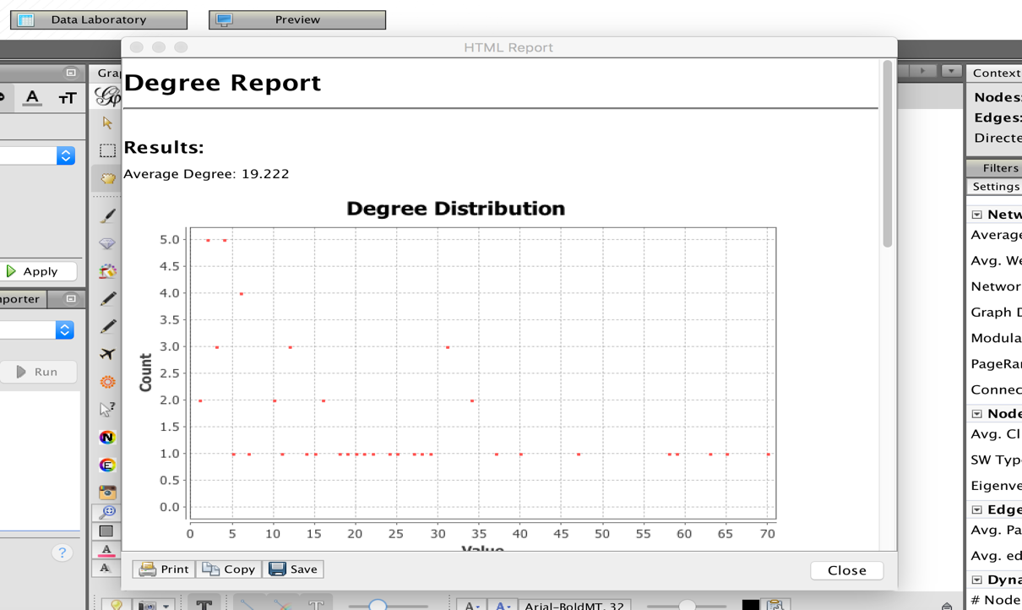

1. Close the degree report and navigate to the Data Laboratory. The new columns- indegree, outdegree, and the overall degree will be added to the nodes table. The picture is shown below:

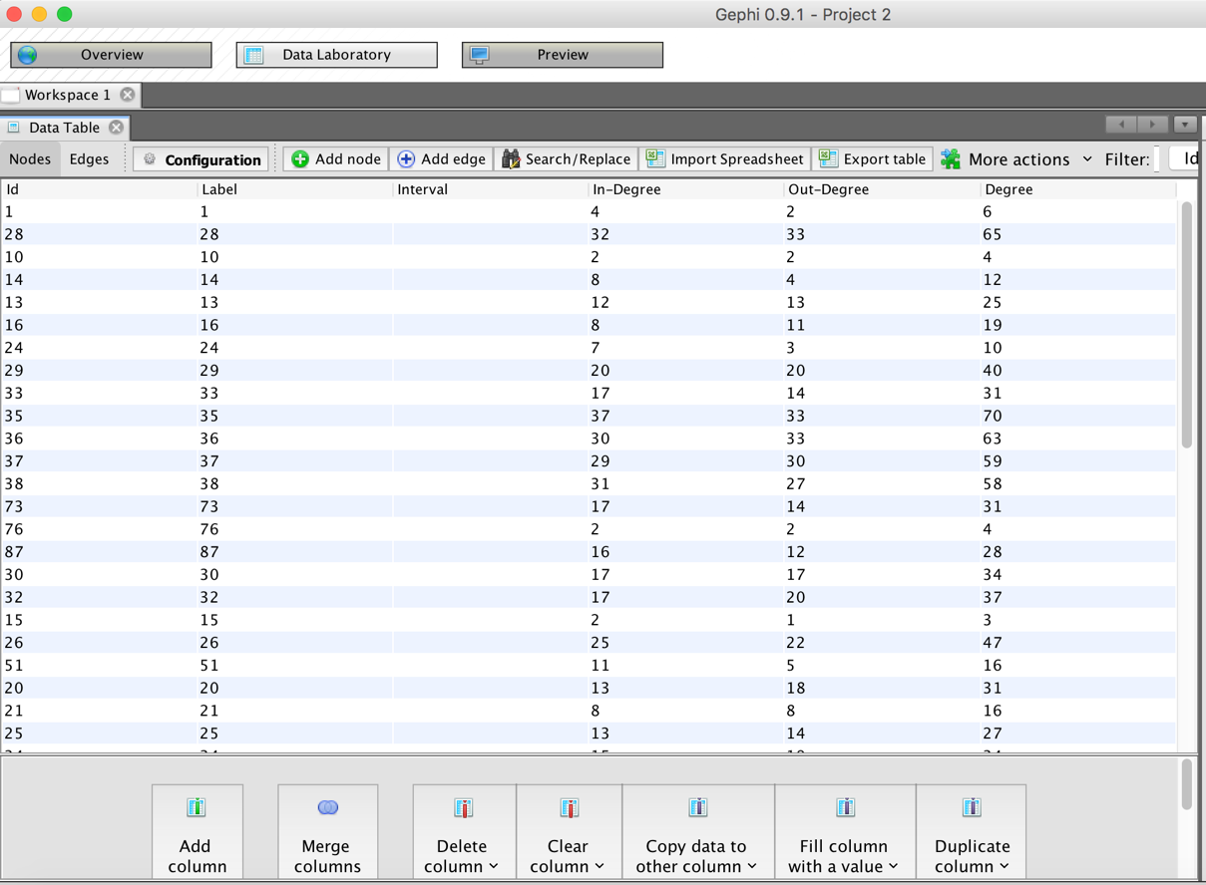

You can also calculate the centrality measures like Betweenness, closeness, eigen vector, and page rank in the similar way. It will automatically detect the type of graph (directed or undirected). Do not bother about various parameters. Just click on the run button.

Now, go ahead and visualize the graph based on various attributes you have calculated.

## Visualization:

### Adjusting the node size:

Navigate to the overview tab. Click on the nodes, then click on the size, then on the attributes. Choose any attribute of your choice and click on the apply button. I chose page rank for the demo. You will observe the change in the size of the nodes. If you want to adjust the scale, click on the spline and play with various control points. Select the best scale that suits your network. Screen shots of each step are presented below:

1. Click on the nodes, and then click on the size and then select an attribute. Each of these buttons are marked in the below picture.

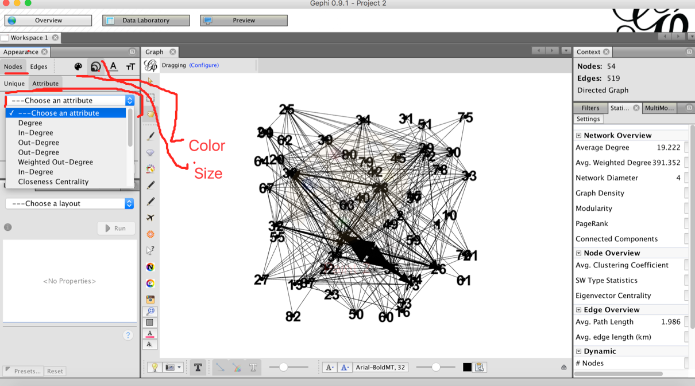

1. Select an attribute and click on apply. This will resize the nodes of the graph.

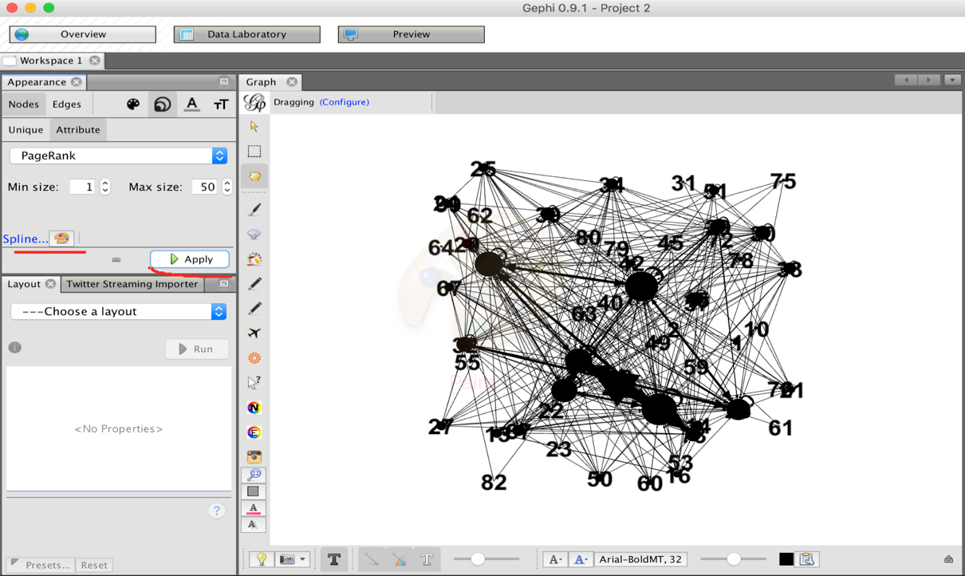

1. Click on the spline marked in the above picture and choose an appropriate function that fits your network. You can either choose the standard template or drag the control point in the display to fit your network as below:

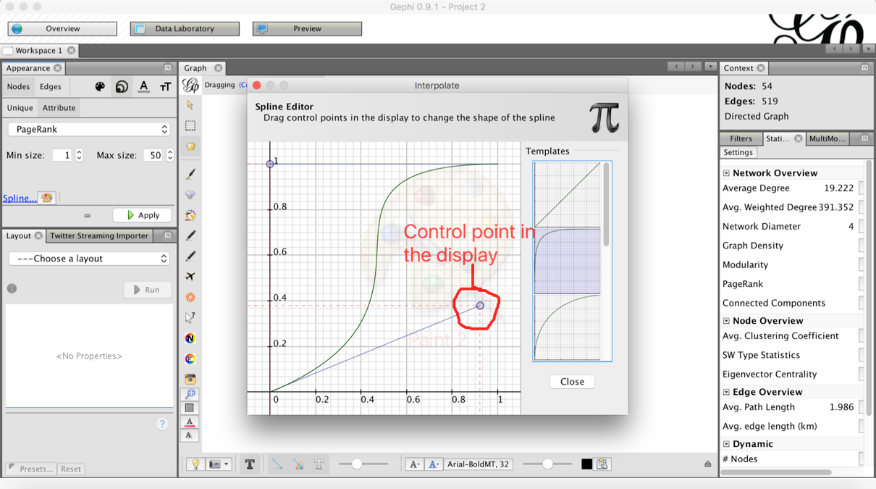

1. Click on apply after selecting the spline and continue doing this until you are satisfied.

(Side Note-1: According to neo-classical economics, preferences of rational individuals are locally non-satiated and their utility functions are strictly increasing. So please don’t get into an infinite loop. It is never going to be perfect. Realizing this fact, I am going ahead without applying the spline editor in the demo. You can still go ahead and complete the visualization even when you don’t understand the side note.)

### Coloring the nodes:

Coloring the nodes is also done in similar manner. Click on the nodes, click on the color and choose an attribute of your choice. You can then go ahead and play with the control points in the spline curve to adjust the intensity of the color from minimum to maximum. Screenshots of each step are presented below:

1. Click on the color and choose an attribute. As before, I chose the PageRank attribute for the purpose of demo.

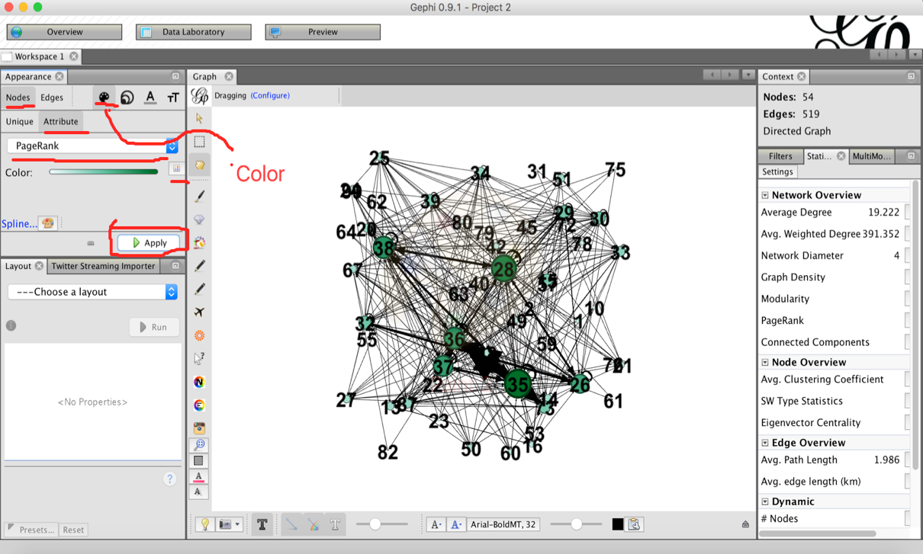

1. You can go ahead and choose the spline editor to change the distribution of color intensity across various nodes as before.

### Scaling the thickness of edges based on their weight:

This option is present at the bottom of the page. You can drag the button and choose and appropriate value that better suits your network. I show two pictures with zero edge weight scale and full edge weight scale.

1. Zero edge weight scale:

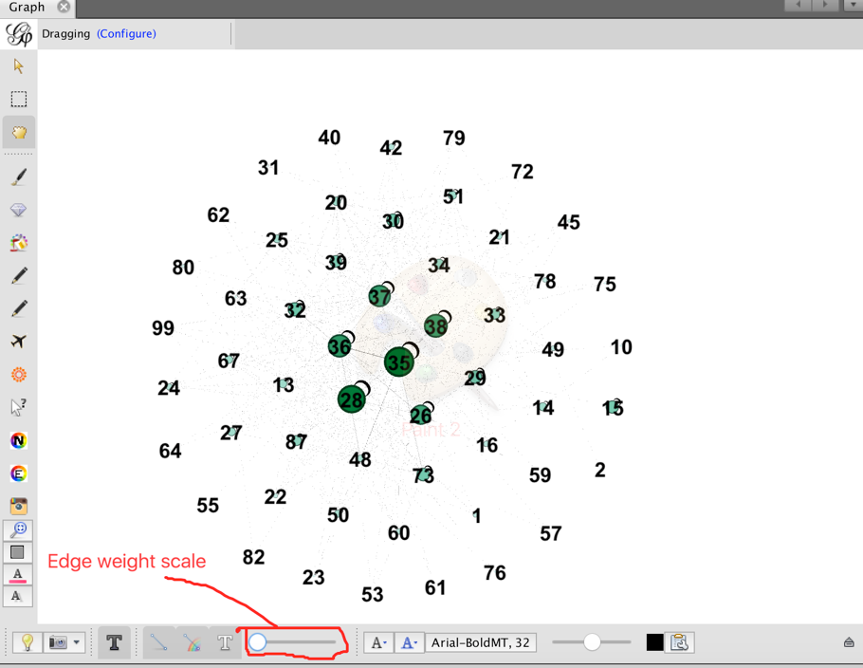

1. Full edge weight scale:

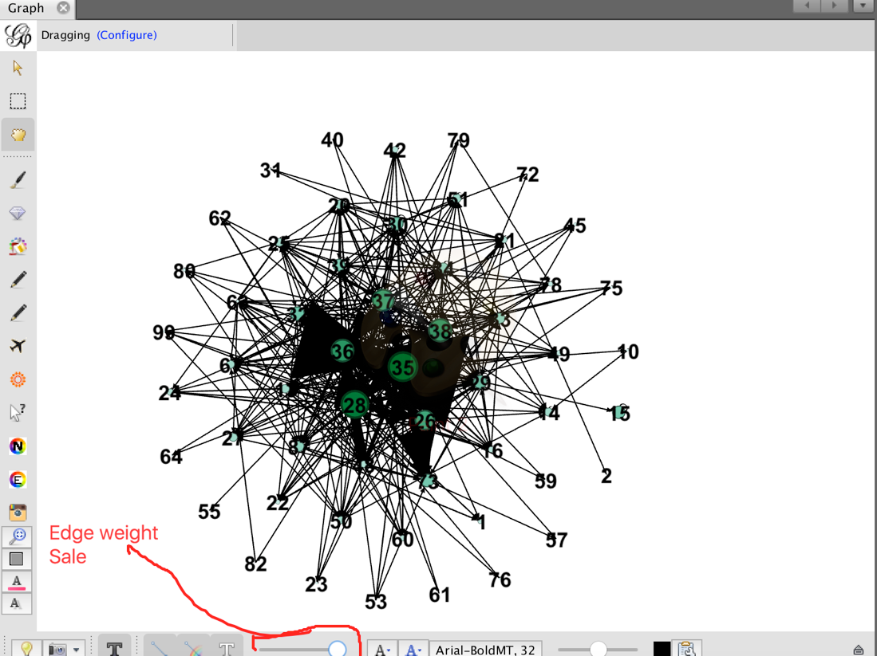

## Exporting the network graph:

1. Click on the preview tab after selecting the appropriate scale of the edge weight. Then click on the refresh button. Initially you may get a completely vague graph as below:

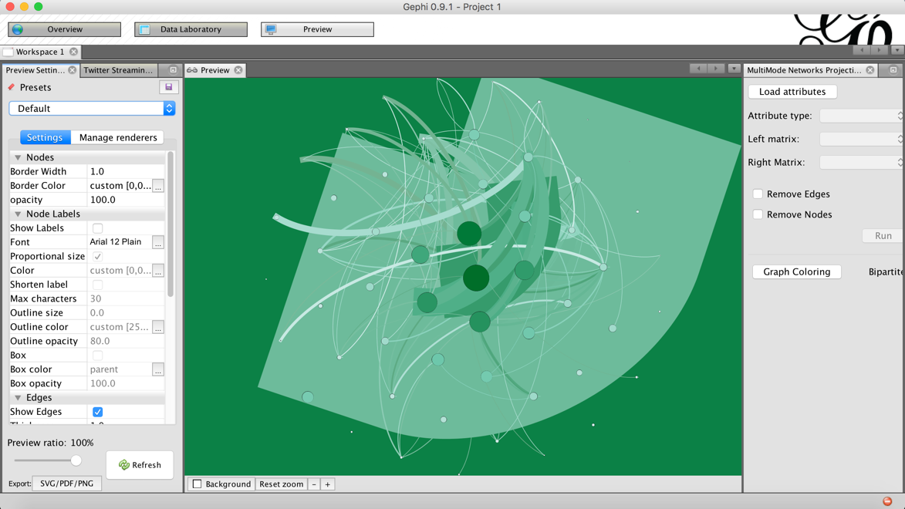

1. Scroll down the settings tab, locate and check the rescale weight option. This will remove the background color. You can also increase the thickness of the color. The new graph may look as follows:

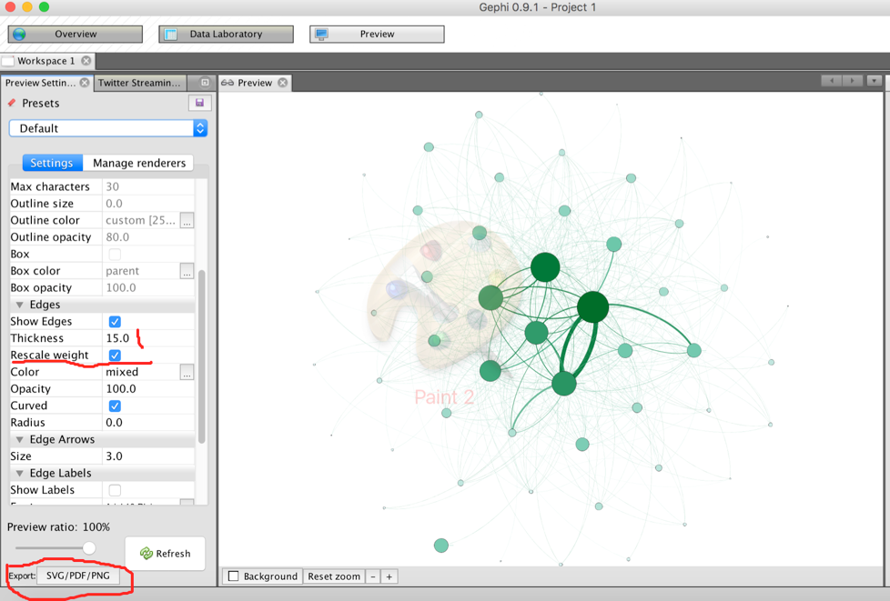

1. There are various other options in the settings tab. You can choose the edge labels, font, thick ness, edges curves etc. When you think you have the graph ready, go ahead and click on the export button. Please save it in the png format, so that you can insert it directly into your report.

